

**George Mason University**

12/9/2022

**Fall**

**2022**

Beakal Abera

Tiarrah Bayne

Jeanie Bailey

Esteban Echandi

**DAEN 690**

**Project Report**

**NLP text classification for SOPs in the Airline Industry**



Table of Contents

Abstract 8

1 Introduction 9

1.1 Background 9

1.2 Problem Space 11

1.3 Research 11

1.4 Solution Space 14

1.5 Project Objectives 14

1.6 Primary User Stories: 14

1.7 Product Vision - Sample scenarios (why would someone want to use this) 15

Scenario #1 15

Scenario #2 15

1.8 Definition of Terms: 15

2 Data Acquisition 15

2.1 Overview: 15

2.1.1 Descriptive Statistics 16

2.2 Field Descriptions: 19

2.3 Data Context: 19

2.4 Data Conditioning 19

2.5 Data Quality Assessment: 20

2.6 Other Data Sources 20

3 Analytics and Algorithms 21

3.1 Methodology Overview 21

3.2 Models/Algorithms 21

3.2.1 BERT 21

3.2.2 Support vector machine (SVM) and Support vector classifier (SVC) 22

3.2.3 Random Forest classifier 23

3.2.4 Principal Component Analysis 24

3.2.5 TextBlob – Parts of Speech tags 24

3.2.6 Nltk Corpus Brown Dictionary – Parts of Speech tags 25

3.2.7 TextBlob – Readability index 25

3.3 Analytics 25

3.4 PDF to text conversion 27

4 Visualization 29

4.1 Embedding visualizations 29

4.2 Machine learning classifiers 34

4.2.1 Support Vector Classifier 34

4.2.2 Random Forest classifier 36

4.2.3 XGBoost classifier 38

4.2.4 Decision tree classifier 40

4.2.5 Stochastic gradient descent 41

4.3 Sequence Analysis 43

5 Findings 47

6 Summary 48

6.1 NLP in a nutshell 48

7 Future Work 50

7.1 Additional annotation for sequence analysis 50

7.2 Simulated dataset to mitigate label scarcity 50

7.3 Ensemble modeling 50

8 Appendix A: Code References 52

8.1 Github 52

8.2 Readme file 52

9 Appendix B: Risk Section 53

9.1 Sprint 1 Risks 53

9.2 Sprint 2 Risks 53

9.3 Sprint 3 Risks 54

9.4 Sprint 4 Risks 55

9.5 Sprint 5 Risks 57

10 Appendix C: Agile Development 58

10.1 Scrum Methodology 58

10.2 Sprint 1 Analysis 58

10.3 Sprint 2 Analysis 58

10.4 Sprint 3 Analysis 59

10.5 Sprint 4 Analysis 59

10.6 Sprint 5 Analysis 59

11 References 60

12 Glossary 61

Table of Figures

Figure 1: Picture of the life cycle of SOPs from Dr. Lance Sherry's paper Modernizing Development, Deployment and Monitoring of Standard Operating Procedures. [3] 11

Figure 2: Canonical Structure of SOP steps - Procedure Representation Language 11

Figure 3: BERT summary view [10]. 14

Figure 4: Annotation tools available [15]. 15

Figure 5: Flowchart of data acquisition 17

Figure 6: Count of features per parent label. 18

Figure 7: Count of features per label. 19

Figure 8: Features text length frequency 19

Figure 9: Annotated SOP example in JSON format 20

Figure 10: Tokens and Vector dimensions 22

Figure 11: Example of 2-dimensional data. 24

Figure 12: SVC Optimal Hyperplane example. 24

Figure 13: Random Forrest classifier example. 25

Figure 14: Part of Speech tag order. 26

Figure 15: Readability index formula. 26

Figure 16: A319-322 after takeoff pdf SOP 28

Figure 17: Converted text file before cleanup and after annotation. 29

Figure 18: Converted text file after cleanup and annotation. 29

Figure 19: Actor associated vector embeddings visualization in 3 dimensions. 30

Figure 20: Label: Action associated vector embeddings visualization in 3 dimensions. 31

Figure 21: Label: Decide associated vector embeddings visualization in 3 dimensions. 32

Figure 22: Trigger associated vector embeddings visualization in 3 dimensions. 33

Figure 23: Verification associated vector embeddings visualization in 3 dimensions. 34

Figure 24: Waiting associated vector embeddings visualization in 3 dimensions. 35

Figure 25: Support vector classifier classification report all labels. 36

Figure 26: Support vector classifier classification report noise labels removed. 36

Figure 27: Support vector classifier confusion matrix 37

Figure 28: Random Forest classification reports all labels. 38

Figure 29: Random Forest classification report noise labels removed. 38

Figure 30: Random Forest classifier confusion matrix. 39

Figure 31: XGBoost classification report all labels. 40

Figure 32: XGBoost classification report noise labels removed. 40

Figure 33: Decision tree classification report all labels. 41

Figure 34: Decision tree classification report noise labels removed. 42

Figure 35: SGD classification report all labels. 43

Figure 36: SGD classification report noise labels removed. 43

Figure 37 Cross-validation for the 5 main models. 44

Figure38 : Labels sequence frequency - Chronological and Alternative 45

Figure 39: Sub labels sequence frequency - Chronological and Alternative 45

Figure 40: Parent label sequence frequency - Chronological 46

Figure 41: Accuracy vs # epoch for the alternative order. 47

Figure 42: Loss vs # epoch for the alternative order. 47

Figure 43: Overall model vs testing 3 new SOPs. 48

Figure 44 Model fine-tunning, parameters and final results. 49

Figure 45: Text classification in a Nutshell 50

Figure 46 Annotation of an SOP: Start point and end point. 51

Figure 47 Ensemble modeling, combination of several models to generate final prediction. 52

Table of Tables

[1] [2]Table 1: BERT Models with their STS benchmark scores. 25

Table 2: Vector 2 rules based on SOPs Flow Chart 29

Table 3: Action label communalities based on parts of speech. 29

Table 4: Labels and methods and algorithms. 30

Table 5: Support vector parameters fine-tuning. 39

Table 6: Random Forest parameters fine-tuning. 41

Table 7: XGBoost parameters fine-tuning. 43

Table 8: Decision tree parameters fine-tuning. 44

Table 9: SGD parameters fine-tuning. 46

Table 10: Sequence frequencies and their results. 48

Table 11: Risks Sprint 1 57

Table 12: Risks Sprint 2 58

Table 13: Risks Sprint 3 59

Table 14: Risks Sprint 4 61

Table 15: Risks Sprint 5 61

# Abstract

Standard operating procedures (SOPs) are step by step instructions used by different organizations to ensure operations are completed in a uniform and safe manner. SOPs are important for safety and efficiency in different critical organizations such as Airlines, Nuclear plants, and hospitals. Airline SOPs contain critical information and actions (steps) that pilots, and first officers must take to ensure safe handling of aircrafts. Since most SOPs currently in use are paper based, they are not usually revised after publication. Our goal is to digitize these paper-based procedures using Natural language processing (NLP) to improve the methodology in which SOPs are engineered and published. This paper uses an NLP model to classify SOP steps into the following categories; Action, Verify, Waiting, or Trigger to generate statistics on the structure of SOPs. The airline industry can use these statistics for testing and training new SOPs in the future. To train the NLP model, the team annotated and collected 45 SOPs. We applied vector embeddings with a bi-directional encoder representations form transformers (BERT) for posterior machine learning classification and particular deterministic rules based on the client’s feedback. Some of the classification machine learning algorithms that were applied who indicated a high accuracy and f1-scores were Support vector, Random Forest, Stochastic gradient descent, and XGBoost. Upon applying these algorithms, these classifiers obtained greater than 80% accuracy and f1-scores. Fine-tuning The team concluded that labels that have a high accuracy are related to deterministic rules present or a particular combination of parts of speech encountered in the features. Labels that contained Where/How were more difficult to predict since the context of the feature interpreted by the algorithm can have a high similarity embedding representation. Further research on sequencing modeling the annotations is recommended to Improve understanding of labels.

# Introduction

Standard Operating procedures (SOPs) are documented step-by-step instructions followed by human operators which are essential to perform critical, repetitive, complex, and emergency-related tasks as efficiently as possible. Due to these aspects and since SOPs play a significant role in any type of process, it is critical to find a systematic method to quantify their information. Many industries utilize SOPs to help train and ensure everyone is aligned on what to do. These are critical in industries such as Airline and Healthcare which are high stake jobs that can result in fatalities. Examples of nonadherence to SOPs accordingly in the aviation industry can be seen in past events and current events as well. The winter of 1982, Air Florida Flight 90 Boeing 737, crashed on the bridge that carries Interstate 395, producing 78 total fatalities. In this case, the NTSB determined that the crew followed incorrect de-icing procedures. “The NTSB determined that the probable cause of the crash included the flight crew's failure to enforce a sterile cockpit during the final preflight checklist procedure.” [2] Another example that can be mentioned was from Air India Express Limited Flight AXB 1344 in 2020 which led to 21 fatalities. The cause of the accident was directly related to specifically not following SOPs. “The probable cause of the accident was the non-adherence to SOP by the PF (Pilot Flying), wherein he continued an unstabilized approach and landed beyond the touchdown zone, halfway down the runway, despite a ‘Go Around’ call by PM (pilot monitoring or first officer) which warranted a mandatory ‘Go Around”. [1]

An effort has been initiated to better understand and analyze SOPs for improvement. “SOP are written, published and tested procedures that are expected to be universally and consistently applied within an organization”. [3]

## Background

For our project, we connected with Jomana Bashatah and Dr. Lance Sherry who were actively working on a draft of a paper titled: METHOD FORMAL ANALYSIS OF THE TYPE AND CONTENT OF AIRLINE STANDARD OPERATING PROCEDURES [4]. As the title suggests, this work looks at Airline SOPs and analyzes the content of these documents. The authors detail the usefulness in analyzing the type and content of these SOPs for ‘proficiency in training’ as well as ‘mission efficiency and safety [4]. To execute this analysis effectively, the paper outlines a method in which Natural Language Processing (NLP) would be immensely helpful in extracting the information out of the SOPs written steps.

The methods used for NLP have been developing over decades. Currently, it is necessary to incorporate Machine Learning (ML) with Neural Networks to achieve high performance [5]. NLP has several associated tasks that are analogous to learning how to read. One task Optical Character Recognition (OCR) is like eyesight in it is how a machine can convert text images into a form it can manipulate in a unique way. It is a way of inputting information. Language has the capacity to cover complex nuances when used amongst people. NLP tasks provide ways to capture these nuances for machines to utilize.

To expand upon the usefulness of analyzing the type and content of Airline SOPs, the SOPs from the Airline industry as well as many others are often written in an ad hoc manner [6]. This allows for needed flexibility but can require significant prior knowledge to fully understand the content described. SOPs are commonly used to provide guidance for those training. When learning new things, it is incredibly useful to be able to recognize familiar patterns, even if it is just the sentence structure. The training process to fly a plane obviously has many key milestones and the SOP reference is one part of this process. The ability to systematically assess SOPs will provide inputs to improve the current process. Breaking down the SOP creating and verifying process can move it from a document drafting exercise to an engineering exercise and provide a way to measure improvement [6]. Below is a snapshot of the purposed SOP modernization which visualizes the process steps primed for improvement [6]. The Chargers team is focusing on the section circled in red to convert pdf documents into digitized records for analysis.

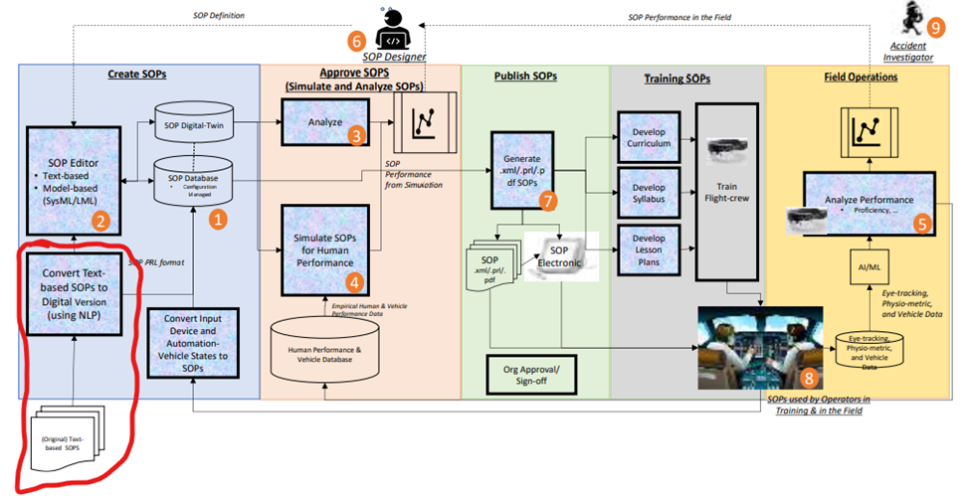

Figure 1: Picture of the life cycle of SOPs from Dr. Lance Sherry's paper Modernizing Development, Deployment and Monitoring of Standard Operating Procedures. [3]

J. Bashatah further describes how to efficiently digitize these text-based SOPs in the context of Procedure Representation Language (PRL) [1],[4]. Figure 2 shows this PRL as labels to use for categorizing SOP steps. UBIAI was introduced in the paper as a tool to annotate procedure steps with the below labels [1]. This not only helped achieve statistical evaluation of SOP step types but also provides a way to train an NLP model.

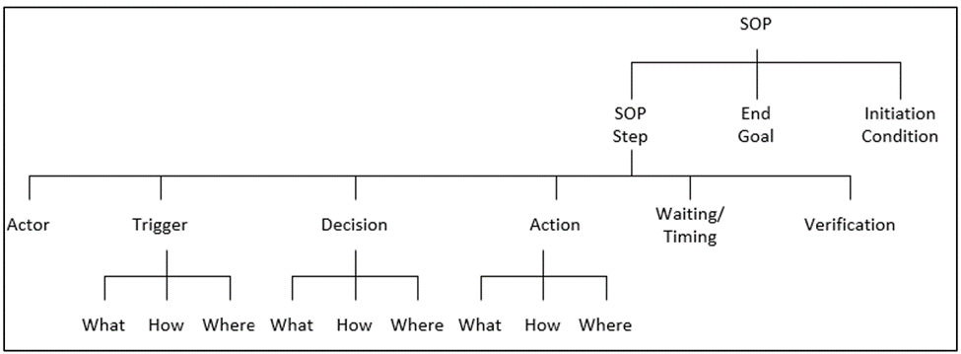

Figure 2: Canonical Structure of SOP steps - Procedure Representation Language

The team was asked to develop an NLP model that can successfully identify these categories of SOP steps. For all modeling, the adage ‘garbage in, garbage out’ applies. To train the model well requires a significant amount of accurate input. Since human interpretation of language can vary, accuracy can be assessed with the UBIAI software’s inter-annotator agreement (IAA) score. This requires multiple people to annotate procedures and returns an assessment of the level of agreement between the annotators.

The process of digitization can take a significant amount of time and effort. This project will also include a script that can convert scanned PDF into text file that can be parsed and annotated using the NLP model. Each contribution to the process moves us closer to the goal and allows us to evaluate the steps taken and try to improve.

## Problem Space

Nowadays SOPs are created manually by a subject matter expert in the field, which is time-consuming and a tedious process to follow. In addition to this, these documented instructions usually are in formats that are difficult to systematically extract any type of data from. The challenge of the project will be to extract useful statistical information from SOPs to help future research on their automation. When this has been created, it has the potential to reduce costs, improve training, and most importantly, increase safety and reduce human error.

The methodology and logic of the project is going to be applicable to SOPs from other fields of interest. However, due to time constraints, our focus is going to be based in the airline industry defined by the operation manuals used by pilots like the Flight Crew Operators Manual (FCOM) or Airplane Flight Manual (AFM).

## Research

For the project, most of our research was done regarding 3 primary areas, Standard Operation Procedures (SOPs), text annotation tools and Natural Language Processing (NLP) with a focus on algorithms that can solve a text classification problem. Below is a summary of the most important topics that are applicable to our project.

General Standard Operation Procedures (SOPs)

A standard operating procedure (SOP) is a documentation of instructions on how to execute a certain work procedure. It can act as a checklist that guides team members on how to carry out complex work tasks effectively and safely. Having SOPs in place ensures that the organization stays aligned regarding standards that will help them achieve their goals and objectives [7].

Standard Operation Procedures Components (SOPs)

* Purpose/Objective
* Step by Step procedures
* Coverage
* Responsibilities
* Ownership/Sign-off of key stakeholders

Why are they important?

* Reduce training time
* Maintains consistency and standardization on a process
* Enhances productivity and promotes best practices
* Meet policies and regulations
* Decreases errors and increase safety

The Airline Industry is what the team is focusing on specifically. The types of Standard Operation Procedures (SOPs) that are going to be focused on are Flight Crew Operators Manual (FCOM) or Airplane Flight Manual (AFM).

Flight Crew Operators Manual (FCOM)

The Flight Crew Operating Manual (FCOM) is issued by the manufacturer as a guideline for operators to develop their own Standard Operating Procedures (SOPs) in accordance with applicable requirements. This source document incorporates aircraft manufacturer guidance on how to use the systems on board the aircraft for enhanced operational safety, as well as for increased efficiency. The FCOM is designed for one specific model, type of operation and configuration [8].

Airplane Flight Manual (AFM)

Airplane Flight manuals and operating handbooks are concise reference books that provide specific information about a particular aircraft or subject. They contain basic facts, information, and/or instructions for the pilot about the operation of an aircraft, flying techniques, etc., and are intended to be kept on hand for ready reference [9].

Natural Language Processing (NLP)

Natural language processing (NLP) is an artificial intelligence area that aids computers in comprehending, interpreting, and manipulating human language. To bridge the gap between human communication and machine understanding, NLP draws on a variety of fields, including computer science and computational linguistics. Natural language processing is not a new subject, but it is progressing quickly thanks to a growing interest in human-machine communication, as well as the availability of massive data, powerful computation, and improved algorithms. Algorithms used for NLP [10].

For our project, the research was focused on Natural language processing (NLP) specifically the text classification area since our project problem to resolve is based on label classification for Action Only, Decision-Action, Action with Waiting-Verification, and Decision-Action with Waiting-Verification on the Flight Crew Operators Manual (FCOM) or Airplane Flight Manual (AFM).

Text classification is the process of categorizing the text into a group of words. By using NLP, text classification can automatically analyze text and then assign a set of predefined tags or categories based on its context. NLP is used for sentiment analysis, topic detection, and language detection [11].

One of the most popular tools that is out there to work with Natural language processing (NLP) specifically - text classification problem is an algorithm invented by Google called BERT. BERT stands for Bidirectional Encoder Representations from Transformers.

Bert is a Machine Learning (ML) model for natural language processing. It was developed in 2018 by researchers at Google AI (Artificial Intelligence) Language and serves as a Swiss army knife solution to 11+ of the most common language tasks, such as sentiment analysis and named entity recognition [12].

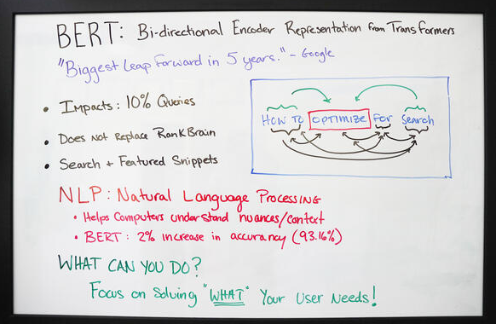

Figure 3: BERT summary view [10].

BERT is made possible by Google's research on Transformers. The transformer is the part of the model that gives BERT its increased capacity for understanding context and ambiguity in language. The transformer does this by processing any given word in relation to all other words in a sentence, rather than processing them one at a time. By looking at all surrounding words, the Transformer allows the BERT model to understand the full context of the word, and therefore better understand searcher intent.

This is contrasted against the traditional method of language processing, known as word embedding, in which previous models like GloVe and word2vec would map every single word to a vector, which represents only one dimension, a sliver, of that word's meaning [13].

Another part of the project in which there was research needed was on how to choose our annotation tool. In this area, we investigated Optical Character Recognition methods and particular annotation tools available in the market and as well open-source options.

Optical character recognition (OCR) is sometimes referred to as text recognition. An OCR program extracts and repurposes data from scanned documents, camera images and image-only pdfs. OCR software singles out letters on the image, puts them into words and then puts the words into sentences, thus enabling access to and editing of the original content. It also eliminates the need for manual data entry. OCR systems use a combination of hardware and software to convert physical, printed documents into machine-readable text. Hardware — such as an optical scanner or specialized circuit board — copies or reads text; then, software typically handles the advanced processing [14].

Annotation Tools Available

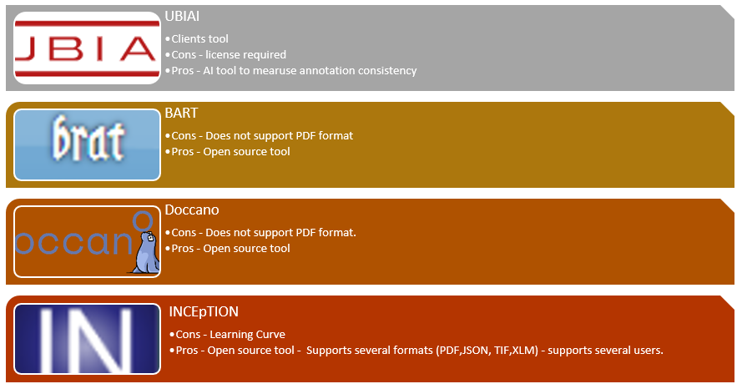

Figure 4: Annotation tools available [15].

## Solution Space

Our NLP model will classify SOPs into the categories and subcategories mentioned above in figure 2. We will use annotated SOPs provided by Jomana and Dr. Sherry and annotate more airline SOPs using UBIAI to train our NLP model. We expect our model to decrease errors resulting from using paper-based SOPs and increase accuracy by using the model for simulation and other engineering purposes.

## Project Objectives

The objective of this project was to develop a NLP model that detects and classifies SOPs into Action, Decision-Action, Action-Waiting-verification, and Decision-Action with waiting-verification.

Currently, the majority of airplane procedures are in paper format where pilots must follow each step accurately. Using paper-based procedures can lead to accidents due to choosing the wrong procedure or choosing to omit a step. “Paper-based procedures are static documents which limit the degree to which the information presented can be tailored to the task and conditions when the procedure is executed” [16]. Our project aims to annotate these paper-based SOPs and convert them into CSV or JSON format to feed our NLP model.

After finishing the project, we assume to achieve a working model to process annotated SOPs which we can use to do engineering, statistics and run simulations to test and improve the accuracy of SOPs.

## Primary User Stories:

Based on the project objectives and value proposition, we developed the following primary user story to guide our project:

* As a flight operator, I want to use computer-based procedures so that I spend less time tracking the correct documentation or procedure.
* As a SOP author or expert, I want to use the NLP model to simulate new SOPs before release so I can test the effectiveness of the SOPs.
* As an airplane manufacturer, I want to implement computer-based SOPs on aircraft to decrease errors and increase safety.

## Product Vision - Sample scenarios (why would someone want to use this)

### Scenario #1

The operating flight crew would benefit from this research. Identifying how past accidents have occurred due to the failure of following directions. Putting specific emphasis on steps that have been missed in the past will allow the operating flight crew to avoid common mistakes.

### Scenario #2

The Federal Aviation Administration (FAA) is the organization responsible for creating the standard operating procedures for airlines to use. The SOPs are in place for the safety of training crew. They should be written in unambiguous language that is easy to understand for all who are using it. Identifying the potential problems from the existing SOPs can aid in the process of writing new ones. Creating a more standardized SOP that is user friendly will help eliminate any uncertainty surrounding the procedures. The caveat to this could be, in creating a new way to write SOPs, new oversights may occur.

## Definition of Terms:

* Standard operating procedure – SOP is a step-by-step instruction used to complete certain processes.
* Natural language processing – NLP gives computers the ability to understand and interpret human text.
* UBAIAI – Computer software used for text annotation.
* Action Only SOP – Step where only an action is explicitly stated in the SOP.
* Decision Action SOP- Step where required information is explicitly stated with the action.
* Action with Waiting Verification SOP- Step where the action has an explicit waiting requirement such as “waiting” followed by an explicit verification.
* Decision Action with Waiting Verification SOP – Step where required information is explicitly stated for the action along with an explicit waiting requirement and verification.
* Optical Character Recognition (OCR) – conversion of images of text into machine-encoded text

# Data Acquisition

## Overview:

Most of the datasets were provided by our client, Jomanna, in JSON format. The remaining datasets were converted from PDF format to JSON by annotating the SOPs using the UBIAI tool. The team developed a process that allowed us to maximize our efficiency with the annotating, the conversion process, and increasing our IAA score. The process began with two of the team members annotating the SOPs, going through the PDF document together. Jomanna did provide the team a flow chart on how to annotate each SOP. However, with the team's limited knowledge on the subject matter, we decided it would be beneficial to annotate in pairs to reduce any second guessing. Once that was completed, the second pair went through and verified what the first pair annotated. After that we discussed any differences, reconciled them and then converted the documents to JSON format. The team merged all the datasets provided and annotated SOPs into one dataset to train our NLP model. To get a more accurate classification model, the team annotated additional SOPs other than the ones provided by Jomanna and Dr. Sherry. The SOPs were from several types of aircraft models and manufacturers which made the dataset diverse and provided sufficient information for our analysis.

Upload PDF SOPs in UBIAI

Annotate using UBIAI

(Half of the team annotates, the other half reviews and verifies)

Export annotated file in JSON format

Figure 5: Flowchart of data acquisition

### Descriptive Statistics

The data was first analyzed for counts of the various label types. Histograms were used to display the results below. The text length frequency was also examined.

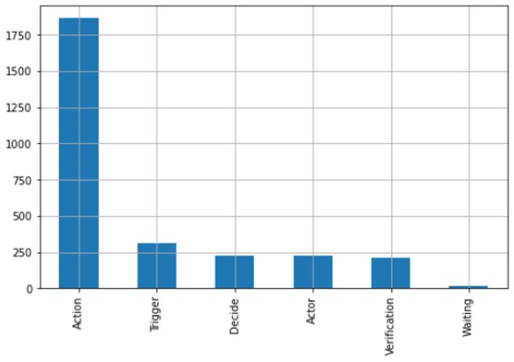

Figure 6: Count of features per parent label.

As seen above, most labels in SOPs were found to be action labels. The Airplane SOPs analyzed contained many actions that pilots and first officers must follow before and after takeoffs. These could be physical actions such as switching a button off or calling out a word to acknowledge a feature is correct. An analysis of more than 40 SOPs suggested that procedures tend to have more Action (What) labels compared to other labels. The study also found that procedures tend not to contain only action labels. Almost all the procedures analyzed contained labels other than action labels.

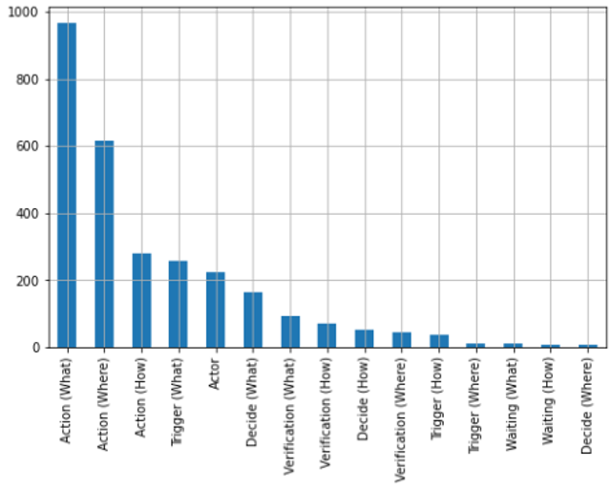

Figure 7: Count of features per label.

Figure 7 shows the counts for the breakdown into the sub-categories for each of the 5 categories that have them along with the Actor label. Something of note is that none of the SOPs analyzed for this project contained Waiting (Where) labels. Therefore, it was not included in the above histogram.

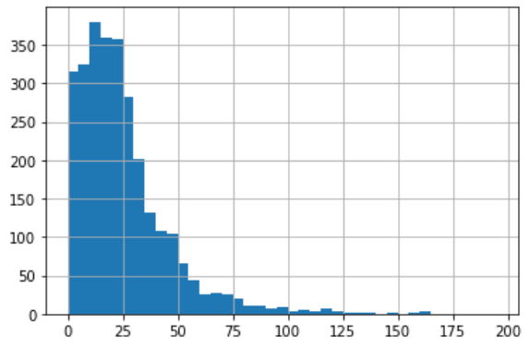

Figure 8: Features text length frequency

## Field Descriptions:

* *Label (Type: string) – Instruction composed by a verb and a sub label determined by either How, Where or What.*
* *Label2 (Type: string) – Instruction composed by a verb only.*
* *Text (Type: string) – Specific text related to the Label, from length 1 to 128 characters.*
* *Document Name (Type: string) – Document or SOP name obtained from the JSON file.*
* *Procedure Name (Type: string) – Procedure name extracted from the Document Name.*
* *Airplane Model Name (Type: string) – Airplane model extracted from the procedure name.*
* *Date (Type: datetime) - Date on when the annotation that generated the label was created.*
* *Document Position Start (Type: int) – Numerical start value of the position of the Label.*
* *Document Position End (Type: int) – Numerical end value of the position of the Label.*
* *Index (Type: int) – Index from 1 through the total records of all SOPs labeled.*

## Data Context:

The dataset contained annotated SOPs from different aircraft manufacturers. The annotated files contained details on the type or category of SOP step, where it is located within the file, and other details about the aircraft. There are two SOP step categories found in Figure 2, verification and waiting, which were not commonly found in the SOPs that we annotated. This meant that the model did not have enough data input for these categories to make confident predictions for them. To mitigate this issue and improve our model accuracy, we had to duplicate some of the SOP lines. Figure 9 is an example of part of an annotated SOP for an A320 aircraft. “label” and “text” are the two most important sections of the annotated JSON files as we use it to classify or predict SOP categories.

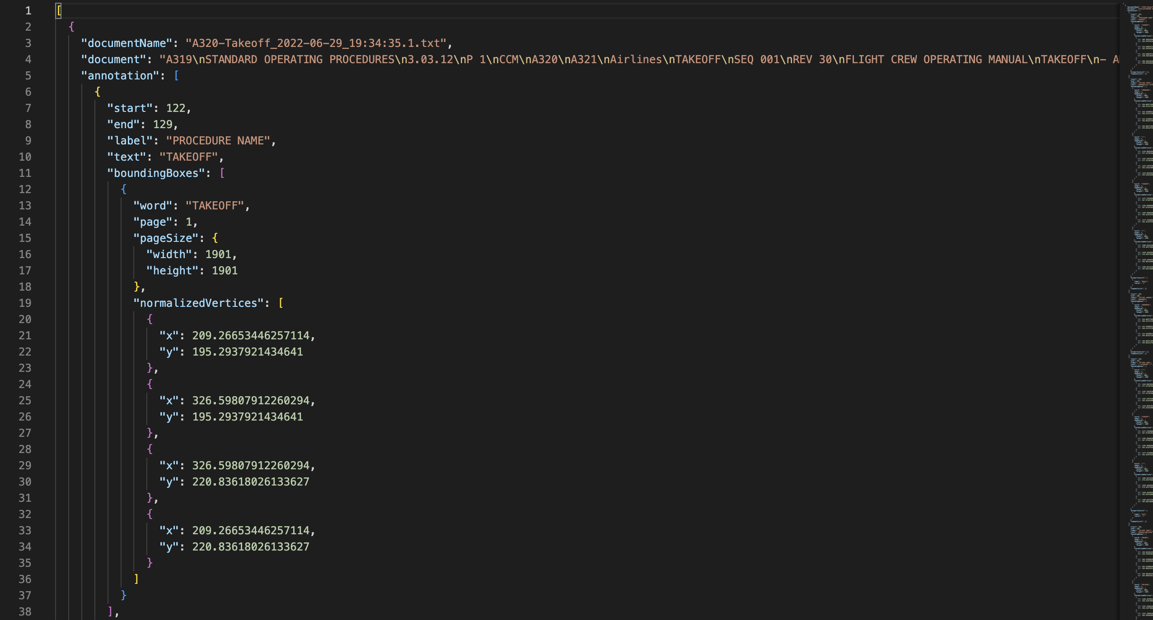

Figure 9: Annotated SOP example in JSON format

## Data Conditioning

Our final dataset was comprised of two types of SOPs. The first was annotated SOPs received from Jomanna. The second was SOPs annotated by the team and then later approved by Jomanna. The first set of SOPs received from Jomanna were already annotated but we had to remove some stop words and perform other data cleaning using Python. This was done to complete the NLP model.

## Data Quality Assessment:

* Completeness: All required values are present in the dataset. Since every SOP is not the same, the excel version of our JSON dataset file might have empty values. This only suggests that every SOP does not contain all the diverse types or categories mentioned in figure 2.
* Uniqueness: All records are unique since all annotated SOPs are unique. There are values that are common within procedures as aircraft manufacturers use similar words in SOPs, but the records are unique as every SOP is unique.
* Accuracy: The annotated SOP was accurate as we used UBIAI score and pair annotation technique to increase dataset accuracy. Our annotated dataset was also checked by Jomana before it was exported to JSON format.
* Conformity: Data types or values are uniform throughout following the standard SOP format.
* Consistency - All columns except 'text' are consistent. All 'index', 'start' and 'end' values contain numerical information.
* Overall Quality: Data generated by 5 different individuals, assessing score with UBIAI score annotation accuracy option.

## Other Data Sources

Other data sources used for the project include the different tables used to complete acronyms and abbreviations which include the definition for those related to the aviation industry. Since the SOPs contain specific language related to the aviation industry, we are using Natural Language processing algorithms

# Analytics and Algorithms

## Methodology Overview

After conducting previous research in the Natural language Process (NLP) domain, the team approached the main task as a text classification problem. Nowadays, there are already several predefined methods that are used when dealing with NLP challenges to try to predict labels and sequences. Text classification, vector semantics, word embeddings, probabilistic language models, and sequence labeling are some examples of usable methods that were accounted for in our project’s research phase.

For the following project, as mentioned in section 1.3, one of the algorithms that stood out when researching text classification and vector embedding was BERT, the bidirectional encoder representation from transformers. This algorithm was selected to explore further because it is ahead of most vector models in the way it analyzes the text from left to right and vice versa which helps the algorithm understand the context from the text. In addition to this, the algorithm is built on the transformer architecture and has been pre-trained with a large corpus of over 2.5 MM words. This algorithm was one part of the data processing steps. There were also different logical inferences based on how SOPs related to the aviation industry are labeled, for example, the structure of the text as well as the parts of speech that each text contains.

## Models/Algorithms

Several models and algorithms were analyzed for effectiveness with the given data. The following sections cover in more detail the way these were applied to our data to provide appropriate analysis.

### BERT

BERT is Google’s neural network-based technique for natural language processing (NLP) pre-training.  It was opened-sourced last year and written about in [more detail](https://ai.googleblog.com/2018/11/open-sourcing-bert-state-of-art-pre.html) on the Google AI blog. In short, BERT can help computers understand the language a bit more than a human does. [17]

#### Tokenization and Word Embedding

The first step in the BERT algorithm required tokenization and word embedding. Figure 10 below was created to represent how BERT calculates the word embeddings. Our vectors are 1024 in length. This is important to tie the data to BERT’s 30K sized vocabulary index. [18]

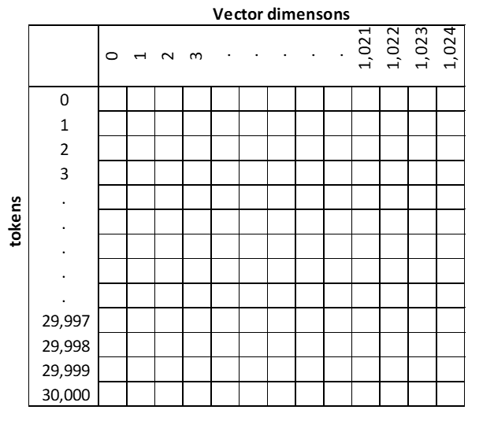

Figure 10: Tokens and Vector dimensions

#### Extracting Embeddings/ Creating vectors

The extraction of the data then was converted into tensors. This process was handled by the huggingface transformers library. This library has a list of pretrained models used to work with vision, audio, and in our case text data.

#### Bert models

For our project, three different BERT models were used, and the performance analysis is shown in Table 1. The best BERT model was called Roberta with the 1000 dimensions vector, and it had an STS benchmark score (Sentence transformers score) of 86.39 points. Bert-large and distilbert had STS scores remarkably close to 86.39. The limitations the team found on using bert-large model was that the words or vocabulary came from the internet only and this can make the model biased. On the other hand, distilbert was a fast and light transformer model as it used small parameters compared to the others.

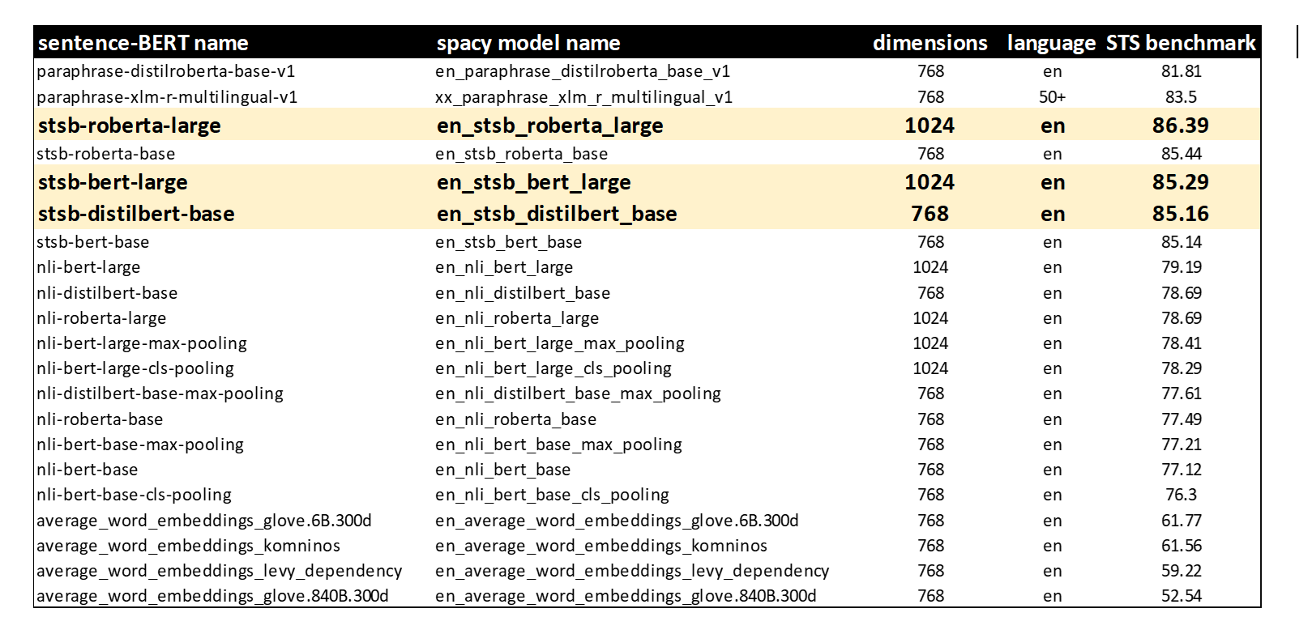

Table 1: BERT Models with their STS benchmark scores.

### Support vector machine (SVM) and Support vector classifier (SVC)

#### Support vector machine (SVM)

Support vector machines (SVM) are used to classify objects or features in N-dimensional space into 2 sides of a hyperplane or line. “The aim of a Support Vector Machine is to devise a computationally efficient way of learning good separating hyperplanes in a high dimensional feature space” [18]. For SVM, data in a low dimension can be transformed to a higher dimension where then we can find a support vector classifier that separates the data into two groups.

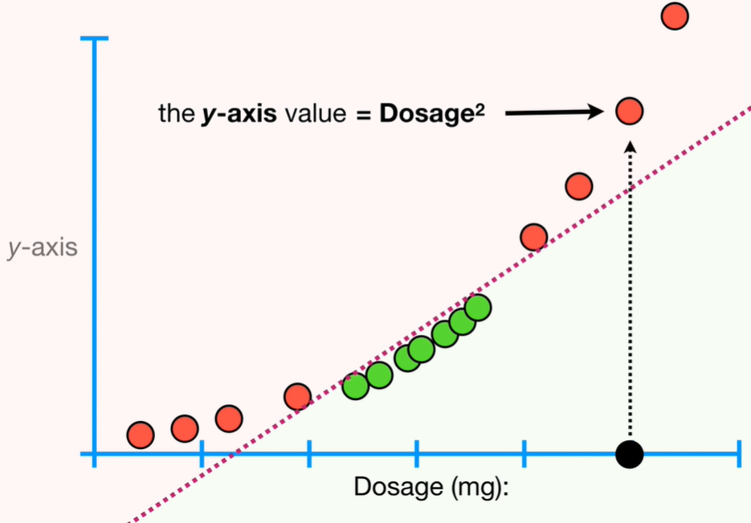

Figure 11: Example of 2-dimensional data.

#### Support vector classifier (SVC)

Support vector classifier (SVC) was trained for this project using sklearn for classifying SOP classes. “SVC works by mapping data points to a high-dimensional space and then finding the optimal hyperplane that divides the data into two classes” [19].

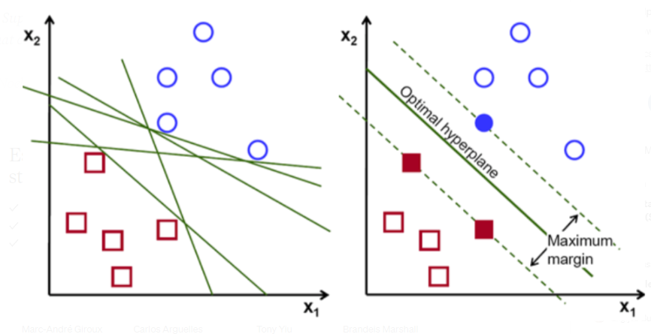

Figure 12: SVC Optimal Hyperplane example.

### Random Forest classifier

Random Forest classifier is another machine learning algorithm used for classification and forecasting business outcomes or decisions. This algorithm selects random samples from a set and constructs a decision tree to get a prediction. This algorithm has advantages over other classification algorithms because it splits the data into many decision tree nodes. Random Forest classifiers have also low instance of overfitting as it aggregates predictions. Our team feared our model would be overfitted due to duplicating data in our training dataset.

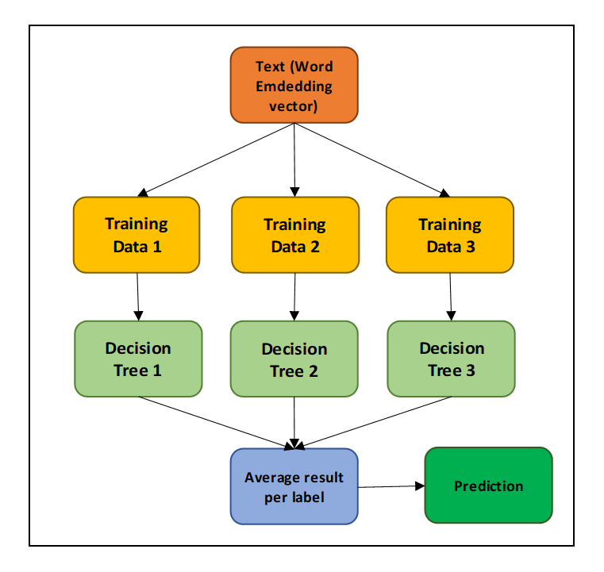

Figure 13: Random Forrest classifier example.

### Principal Component Analysis

Principal component analysis is a statistical procedure that allows you to summarize the information content in large data tables by means of a smaller set of “summary indices” that can be more easily visualized and analyzed [20]. This provides a means to reduce the vector’s dimensions.

Vector Dimensionality reduction of dimensions n=2 and n=3 will be used as part of our algorithms to reduce the vectors provided by the BERT model for further analysis and visualization purposes.

### TextBlob – Parts of Speech tags

Textblob is a python package that was selected to help tag parts of speech (POS) from the different text that the raw data had. Text with this algorithm is tagged based on Parts of Speech tagging context and then assigned the highest probability to what it can be tagged with. For example, if the sentence or text starts with the word pack, the algorithm will prioritize the noun or preposition before the verb.

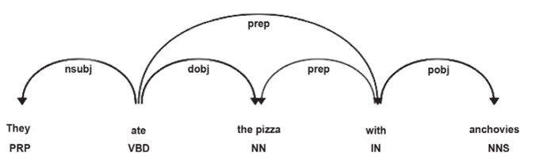

Figure 14: Part of Speech tag order.

### Nltk Corpus Brown Dictionary – Parts of Speech tags

To bypass the normal parts of speech prioritization that Textblob has and to mark any parts of speech that a word can have, we proceeded to use the NLTK corpus for the brown dictionary which has all parts of speech for all words in the English language. With this new method, the team was able to automatically tag labels that should start with a verb like for example the Action (How) cases which helped to increase the accuracy of the overall model.

### TextBlob – Readability index

In addition, the team also processed the text with a readability score that is based on the formula from Figure 15, this method helped clean much more of the data and made sure the algorithm was recognizing the text on the raw data. Any high negative readability score was eliminated from the calculation when the team confirmed with the context of the text and actual SOP document.

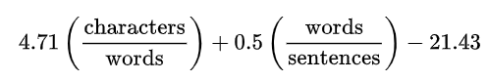

Figure 15: Readability index formula.

## Analytics

SOPs of any industry will contain text, certain rules/standards regarding labels and parts of speech that can help us understand different communalities that text might have with the predicted labels.

Our original model only contained 1 vector of information provided by the BERT algorithm associated explicitly with the word embeddings overall text. This is useful for some labels that show high accuracies and are understood by similar contexts portrayed on them. SOPs text in some cases follows certain rules that the original algorithm will not account for.

For this reason, the team decided to create another vector that solely looked at these deterministic rules to increase the accuracy of the model. Below are the rules that the algorithm took and created unique vectors for the following text that start with the labels enclosed in Table 2. Decide (What) labels contained “if” at the beginning or within a sentence. This made the classification process easier for Decide (What) labels. Action (Where) and Verification (Where) labels were harder to predict because the same tools, for example levers or a monitor, used to verify an SOP process can be used to perform an action.

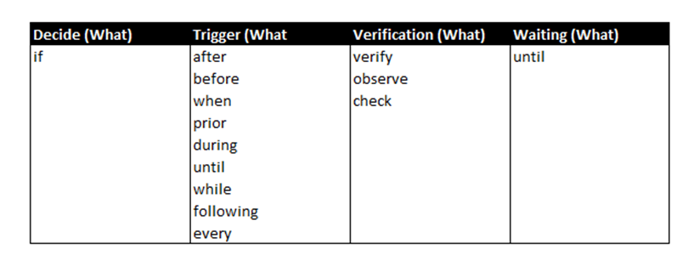

Table 2: Vector 2 rules based on SOPs Flow Chart

In addition to this, to further improve the model, part of speech (POS) tagging was also used to account for different labels that have similar patterns. For example, Action (How) labels will be associated with a Verb as they are related to some action being performed by pilot or first officer. Enclosed in Table 3 are some of the rules regarding POS that the team incorporated.

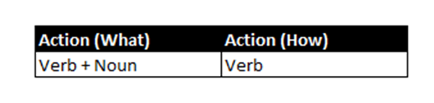

Table 3: Action label communalities based on parts of speech.

This was achieved with a python library TextBlob which has a variety of diverse ways to organize or classify the text associated with our designated labels. For example, the Part-of-speech tagging shows the parts of speech in each labeled text which may be useful to associate parts of speech that are highly correlated with labels like verbs and the action label for instance.

As a summarized view of the analytics and logic mentioned before is the following table 4.

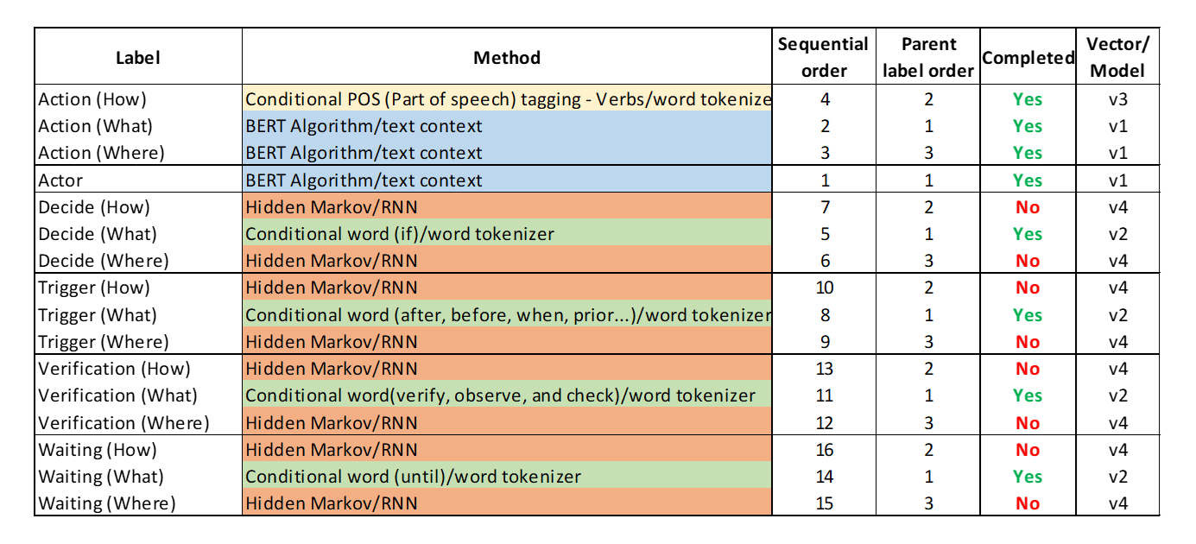

Table 4: Labels and methods and algorithms.

## PDF to text conversion

As mentioned earlier, many SOPs in circulation are in a pdf or scanned pdf format. For this reason, there needed to be a process in this project that converted paper pdf SOPs to digital format where it can get parsed and then annotated using the NLP model created. Using python, Pytesseract module, it was possible to create a script that takes a PDF as an input and gives a text document as an output. The text file is cleaned, parsed, and run in the model to annotate the text. The SOP below, A319-321 after takeoff SOP, was tested in the PDF conversion script and the text file (figure 18) was the final output after cleanup and parsing.

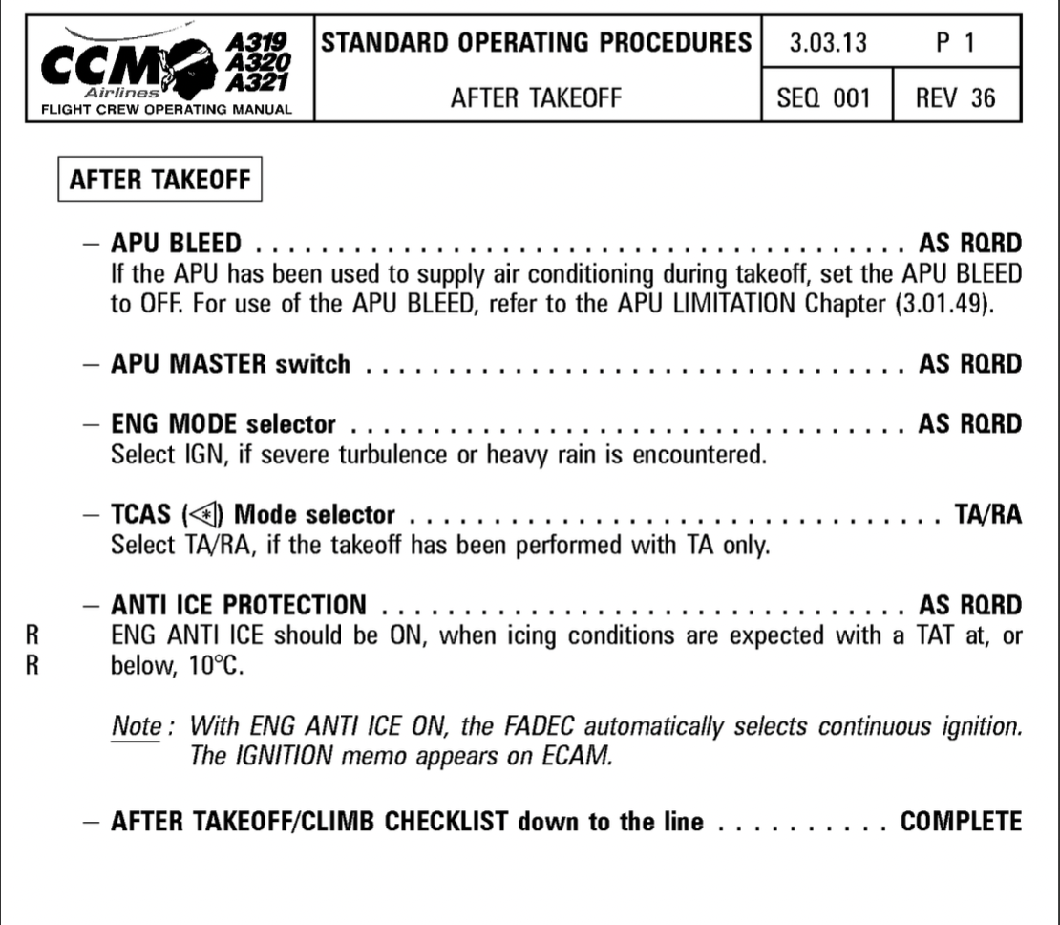

Figure 16: A319-322 after takeoff pdf SOP

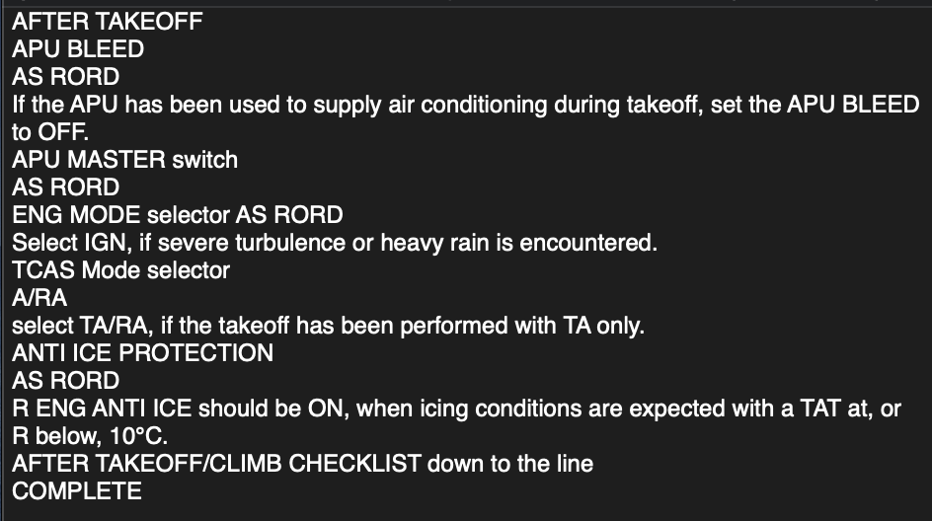

Figure 17: Converted text file before cleanup and after annotation.

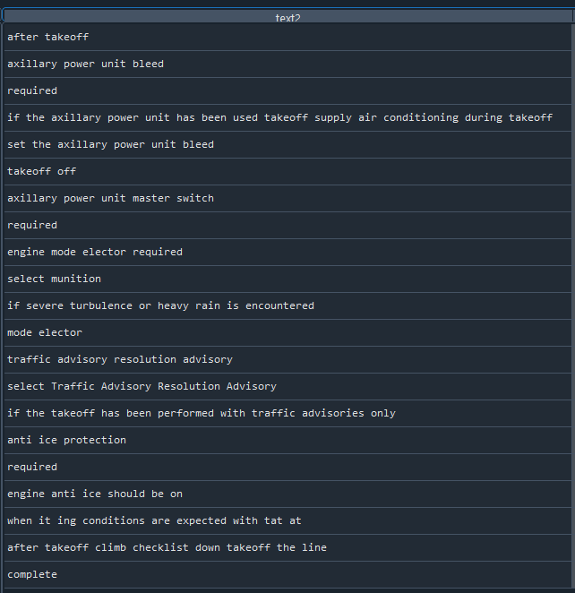

Figure 18: Converted text file after cleanup and annotation.

# Visualization

## Embedding visualizations

To visualize the vector embeddings with 1024 values, the following visualizations were created after performing data transformations using principal component analysis (PCA) with 3 dimensions. The purpose for embedding visualizations is to explore the data further and understand the relationship between the different labels and the vector embeddings. The following visualizations were separated by the different parent labels (Actor, Action, Decide, Trigger, Verification, and Waiting). To keep the same frame of reference the actor label was left to easily compare the clusters on the graph.

For the Actor associated vector embeddings, it can be seen on the visualization below that there are 3 clusters for this label. The fourth label is not well defined due to the number of instances. For the clusters that are well defined, we can find the following associated text to them. For the first cluster the text related to it is “pilot flying”, for the second cluster its “pilot not flying”, for the third cluster will be anything related to “captain” and the dispersed fourth cluster will be anything associated with “crew”.

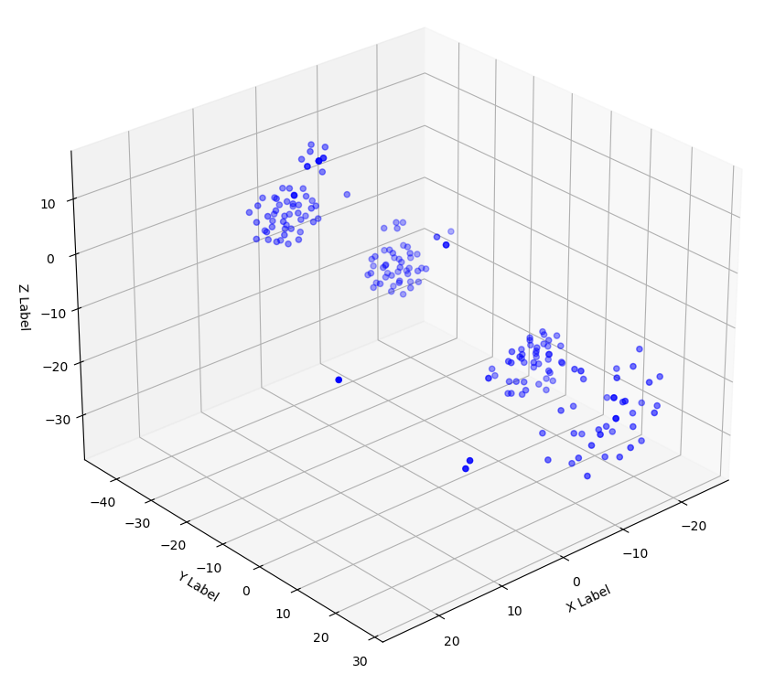

Figure 19: Actor associated vector embeddings visualization in 3 dimensions.

Action Label is the most frequent label in the data set as SOP creation guidelines recommend using action words when creating SOPs. The action label has three important aspects that can be noticed in the visual below. The first aspect is that more than 80% of our records are associated with this label, is the reason why the scatter plot shows a much denser view than the rest of the labels. Secondly, there are clear clusters for Action (How) label and this label is associated with a particular verb in most of the annotations. There are also some scattered labels that are not related to verbs that probably are related to human error on the annotation or issues with the Part of speech algorithm that could not detect a potential verb. Thirdly, it is important to mention how the What and Where label is scattered through the whole visualization when seen on the 3D plot with no clear direction.

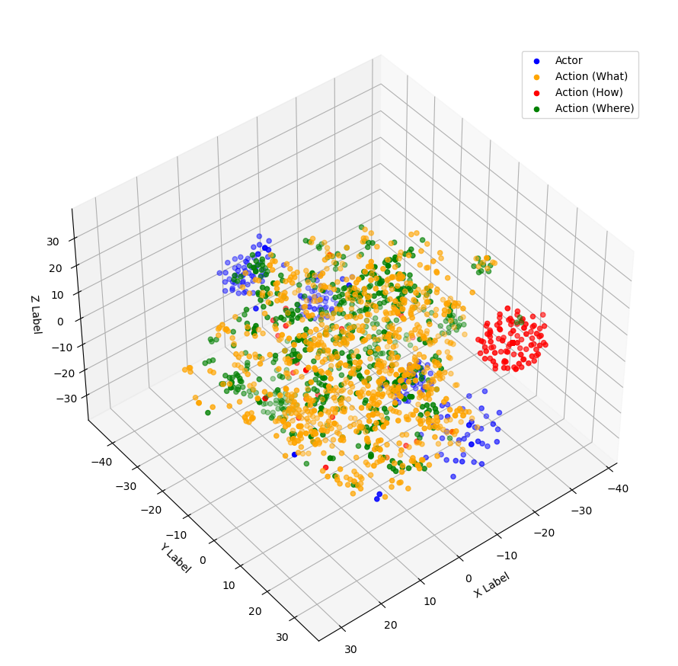

Figure 20: Label: Action associated vector embeddings visualization in 3 dimensions.

For the decide label, the most critical aspect that can be pointed out from the visualization below (figure 21) is the cluster related to Decide (What) label. The reason for this is associated with the fact that this label follows a deterministic rule established by the model. This predefined rule is that any annotation that starts with the word “if” will be considered as a decision, specifically a decision (what) label. Clustering is somehow spread due to the multiple contexts that can be inferred with sentences or texts containing an “if” statement.

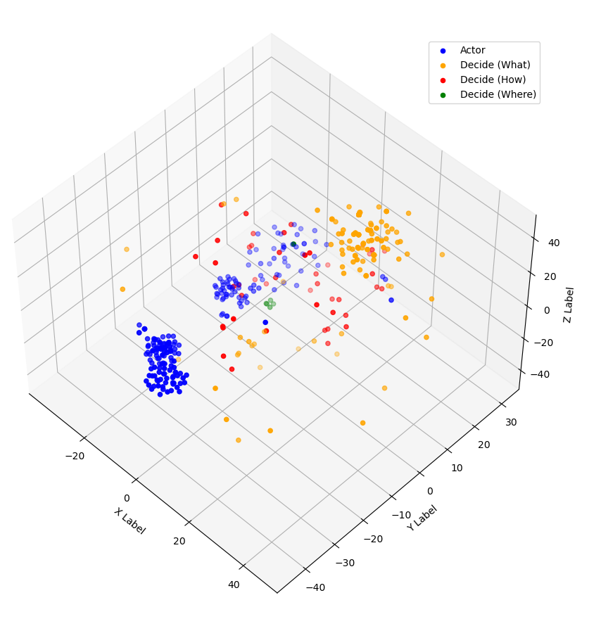

Figure 21: Label: Decide associated vector embeddings visualization in 3 dimensions.

Trigger label does not have a deterministic rule that is followed by the embedding Tigger (What) that has a clear set of clusters. Clusters for this label are identified by words in the label that start with the following strings (after, before, when, prior, during, until, while, following, every, and within). These identifying words are related to a preposition that act as a trigger word for the actor to take action or verify.

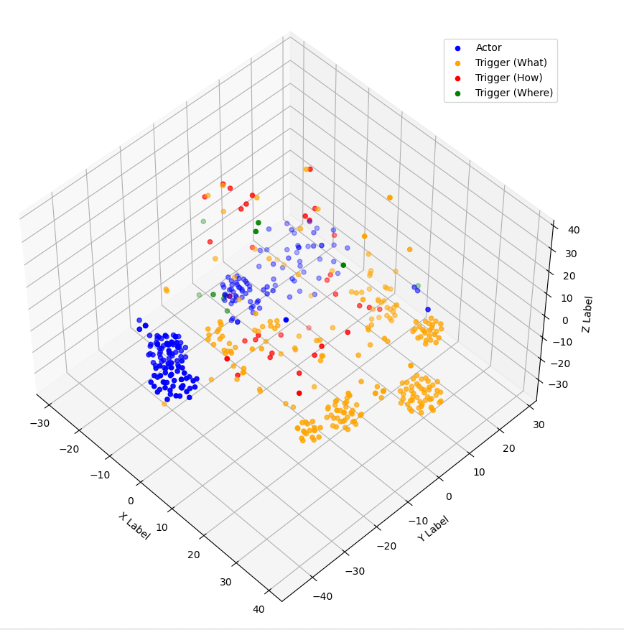

Figure 22: Trigger associated vector embeddings visualization in 3 dimensions.

Different from the trigger label, verification label shows one predominant cluster related to strings that start with verify, check and observe. These are exceptions to the deterministic rules associated with Action (How) verbs, since they are accompanied by additional context on the sentence, while the Action (How) label is just a single word that must be a verb. In addition, for the Trigger (How) and Tigger (Where), there is not a defined cluster and in some cases labels specially for Tigger (Where) are scarce.

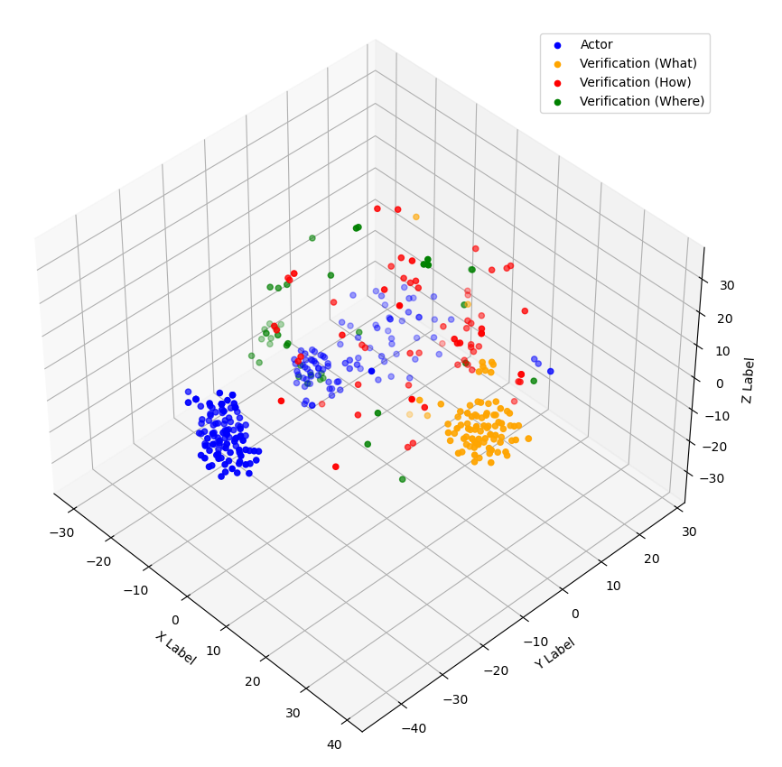

Figure 23: Verification associated vector embeddings visualization in 3 dimensions.

The waiting label has the least number of instances of 20 in the dataset. For this reason, it does not have a clear predominant cluster in the visual below. The only possible cluster is generated by the string “until”, which creates a small cluster on the lower section of the plot.

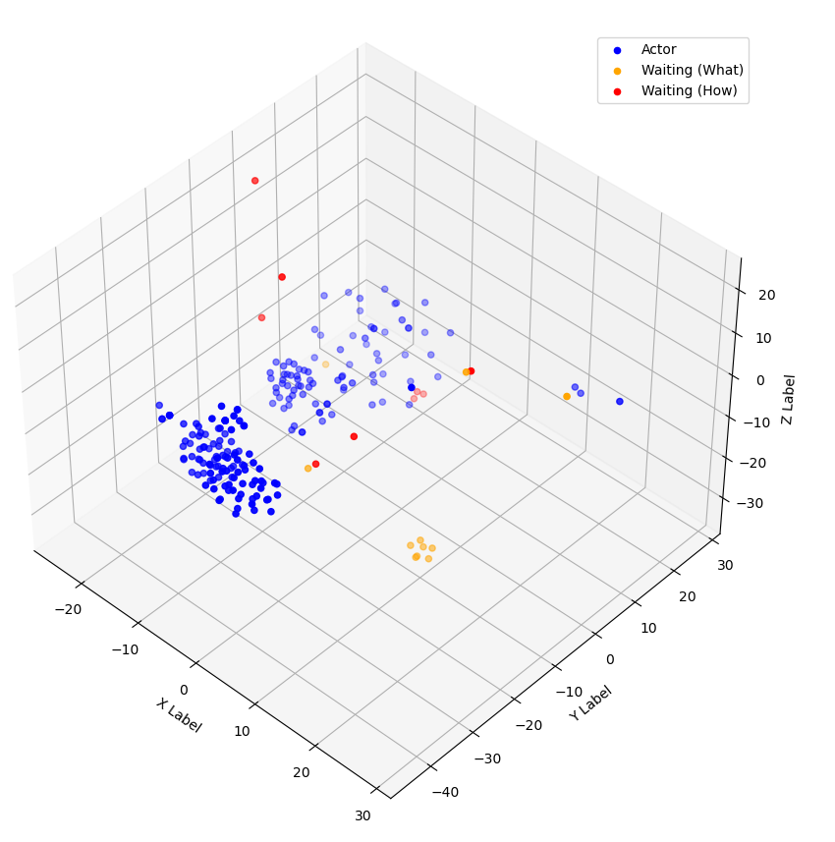

Figure 24: Waiting associated vector embeddings visualization in 3 dimensions.

## Machine learning classifiers

The following visualizations show the performance of the five machine learning classifiers used following the sequence analysis for several different label iterations. The team chose to display the models’ prediction accuracy along with each label’s performance to highlight the variation in prediction power depending on the label. The confusion matrices provide more detail around the number of correctly and incorrectly predicted labels for the best performance models. In addition, the fine-tuning parameters are as well shown which helped increase the f1-scores of each machine learning classifier.

### Support Vector Classifier

In the following heatmap, the precision, recall and F1 score is shown for each of the labels and an overall accuracy is displayed. This shows the results from the support vector classifier model and some labels have extremely high values while others show exceptionally low values. The model struggled with the Trigger (How), Trigger (Where), and the Waiting (What) labels because as shown in section 2, there were not very many of these labels at all. Even though Decide (Where) had low instances in the dataset, the model showed great accuracy for this label.

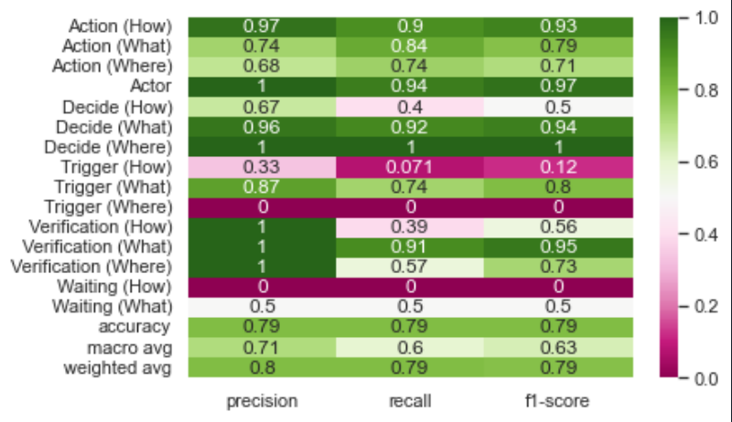

Figure 25: Support vector classifier classification report all labels.

The heatmap below shows the SVC model with labels that had a frequency higher than 20 samples which helps clean the dataset and reduces the noise on the model. Compared to figure 25, we removed labels like Decide (Where), Waiting (What) and Verification (Where) to reduce noise.

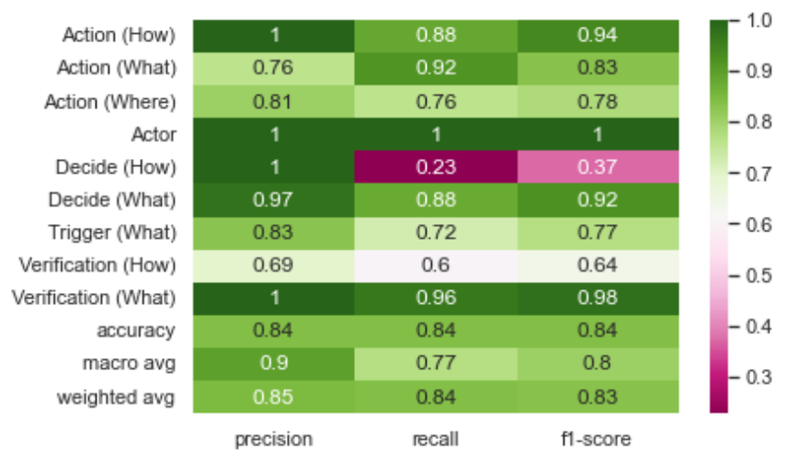

Figure 26: Support vector classifier classification report noise labels removed.

For model tuning, the C, gamma, and kernel parameters were tested, and the visualization below shows the best results in which the SVC performed. As it can be seen below on table 5, a C value of 10, the gamma parameter set as auto, and the kernel as poly gave the best results with 84.19% accuracy. Nevertheless, there are also other results with the kernel set as linear that performed relatively similar to our best result.

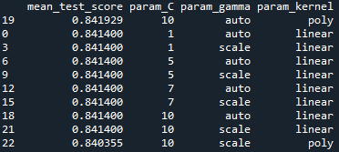

Table 5: Support vector parameters fine-tuning.

The confusion matrix below shows the predicted vs true labels from the same support vector model. Here, the accurate labels are counted across the diagonal and the incorrect labels are counted in the associated spot. For example, there were 12 Trigger (What) labels predicted to be Action (What). The actor is the most accurate label based on the confusion matrix below. This is mainly because the Actor label only had a few unique words related to it and the algorithm can easily detect these words.

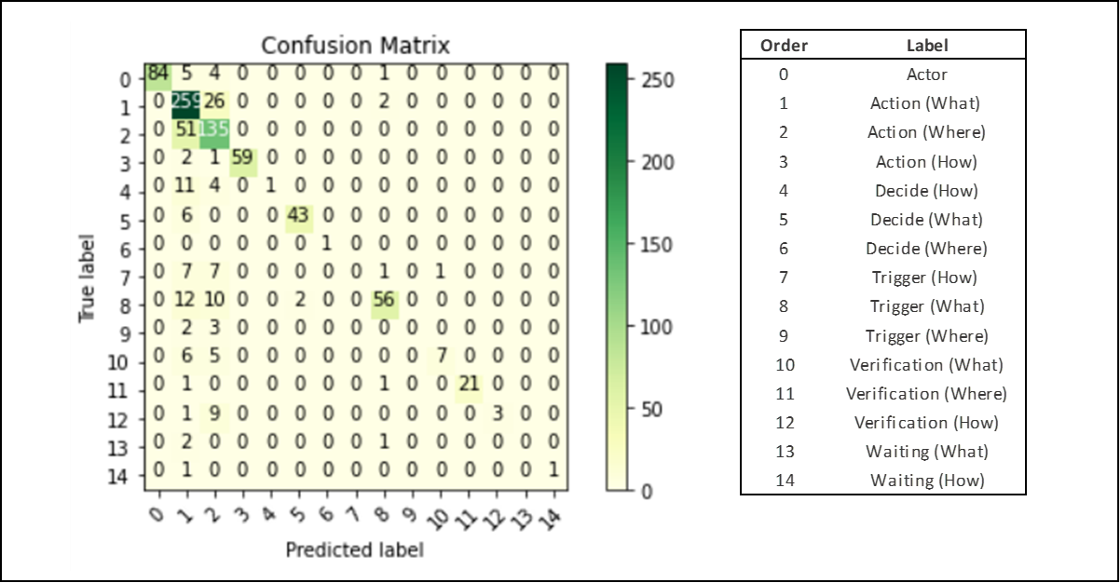

Figure 27: Support vector classifier confusion matrix

### Random Forest classifier

The heatmap below displays the accuracy scores for the random forest classifier. Similarly, to the support vector classifier, there are low scores associated with low the low quantity labels. Compared to Support vector classifier, the random forest classifier has lower precision and overall f1-score.

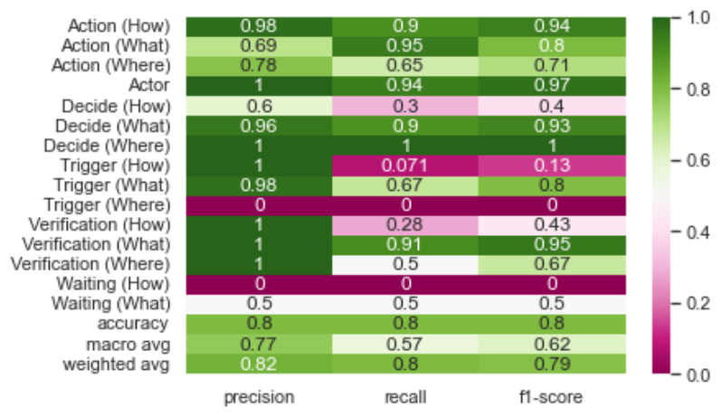

Figure 28: Random Forest classification reports all labels.

Below is the heatmap for the random forest model with labels that had a frequency higher than 20 samples which helps clean the dataset and reduces the noise on the model. Only including labels with high frequency also decreased scores on some of the labels like Action (What) and Decide (How). This can be associated with the fact that some labels are dependent on other labels and removing them to reduce noise has had a negative effect on the dependent labels.

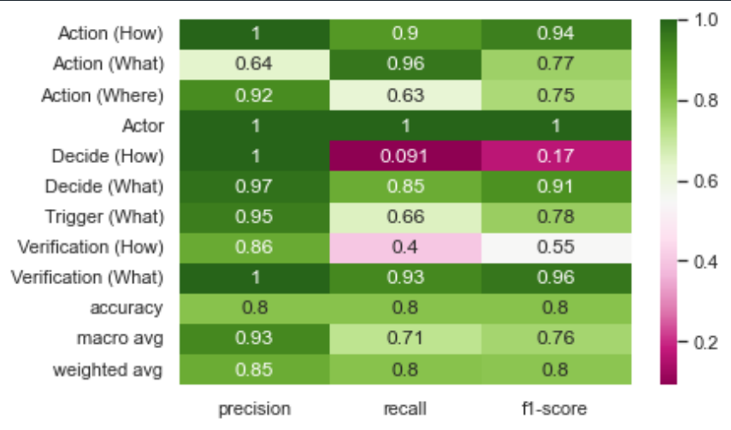

Figure 29: Random Forest classification report noise labels removed.

For fine-tuning the random forest, the team worked with 3 main parameters which were the criterion, number of estimators, and the max depth. As can be seen from the table below, the best results were achieved by setting up the number of estimators to 500. It is important to mention that for max depth parameters of 1,000 or 100 results remained the same.

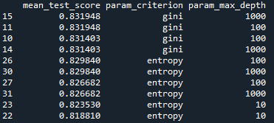

Table 6: Random Forest parameters fine-tuning.

The confusion matrix below displays the results from the random forest classifier. Just like above for the support vector classifier, the confusion matrix shows the number of predicted labels and the true labels. For reasons mentioned above, Actor is great accuracy based on the confusion matrix with all 83 instances being correctly predicted. Verification (where) was also perfectly predicted, and this was a surprising result as the team and algorithm had difficulty during the initial stages of the project correctly predicting or classifying Verification (Where) and Action (Where) labels correctly.

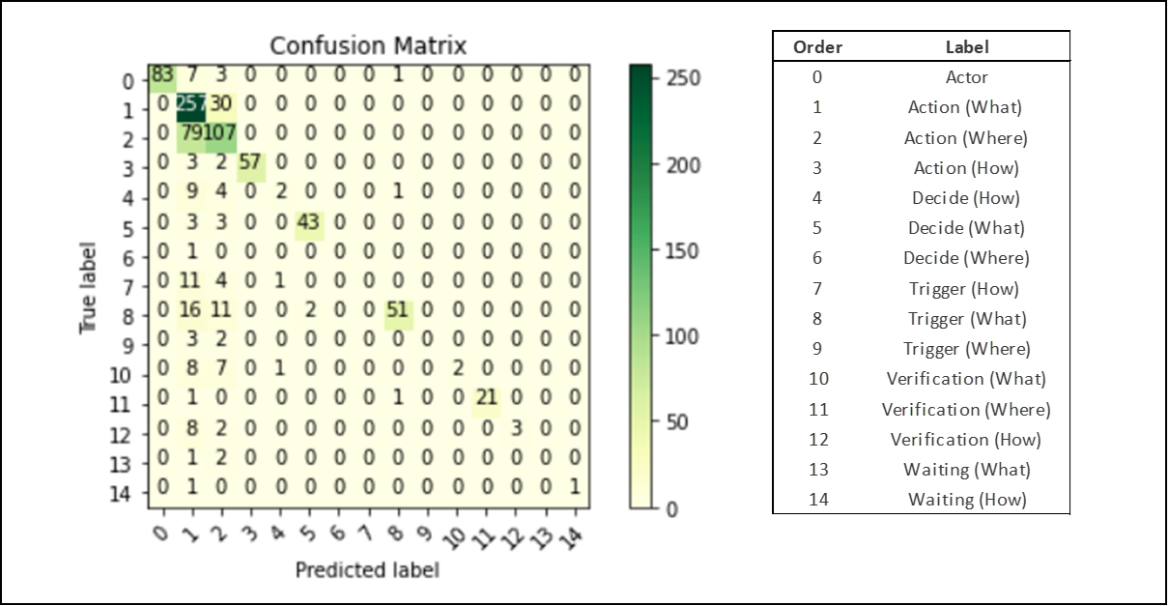

Figure 30: Random Forest classifier confusion matrix.

### XGBoost classifier

In addition to the previous model mentioned above, an XGBoost classifier was also implemented and below the accuracies for the whole dataset. Similar to the random forest this particular model reached a 80% accuracy with fine-tuning the parameters b

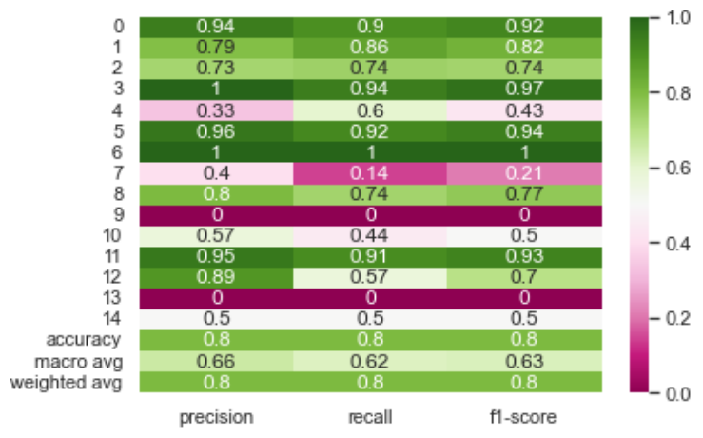

Figure 31: XGBoost classification report all labels.

Similar to the steps taken for the other models, we cleaned up the noise by removing some label instances from the raw dataset to test if it can increase the scores. Most of the label scores had higher than expected result except for the how related labels on verification and decide.

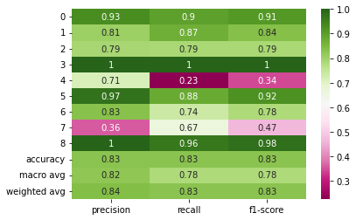

Figure 32: XGBoost classification report noise labels removed.

For the fine-tuning process, the following parameters were used for testing. We were able to include booster, number of estimators, and max depth parameters. As it can be seen on the table below, the gblinear gave the best results for booster and increased the number of estimators to any value greater than 10. Using the parameters mentioned above, the accuracy of the XGBoost reached 84.40% which was one of the best predictions.

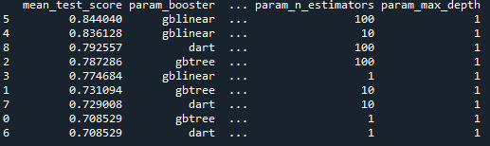

Table 7: XGBoost parameters fine-tuning.

### Decision tree classifier

To experiment with other classification models, the team added a decision tree classifier as well to the project. Accuracies even with fine-tuning didn’t surpass 80%. Enclose the model below for the whole data set.

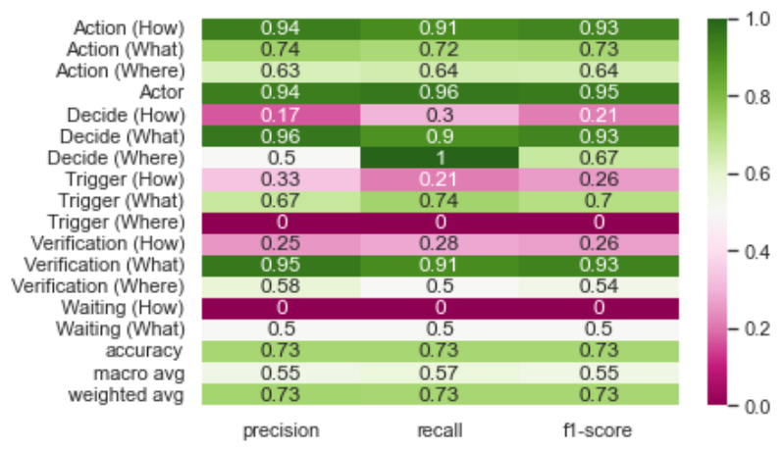

Figure 33: Decision tree classification report all labels.

Like what was performed for the rest of the model, noisy data was removed, and the model was passed through the new dataset and model.

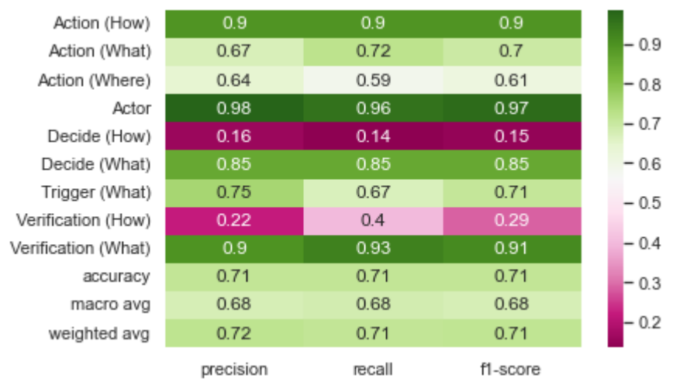

Figure 34: Decision tree classification report noise labels removed.

When fine-tuning was performed the best results were achieved by using gini criterion, splitter set as best, and the max depth optimized at 100. These parameters joined together created an accuracy of 75.73% for this model.

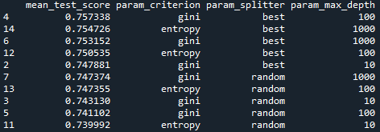

Table 8: Decision tree parameters fine-tuning.

### Stochastic gradient descent

In addition to the previous models discussed, the Stochastic gradient descent classifier was also implemented, and it gave also interesting results greater than 80%. For the whole dataset the accuracy score estimated is 81%. It is important to mention that this particular model had the best precision score when accounting for all the dataset similar to the random forest model.

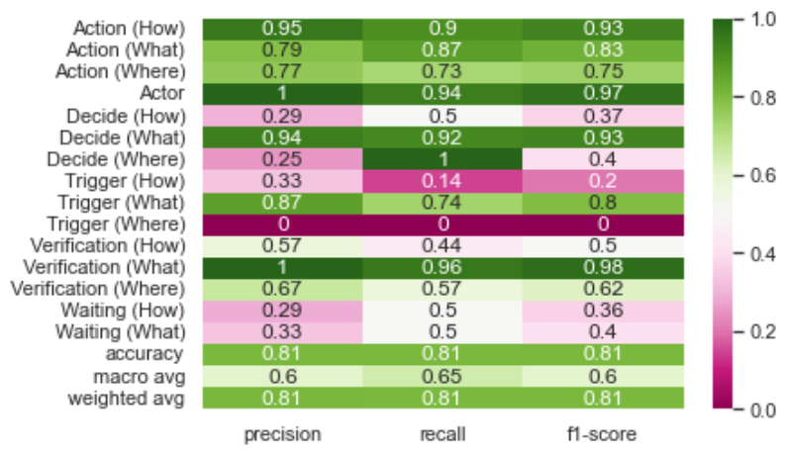

Figure 35: SGD classification report all labels.

When noisy data was removed, the accuracy increased to 83% without fine-tuning. For decide (how) and verification (how) labels, this model was the best performer to measure precision, recall, and f1-scores for this label.

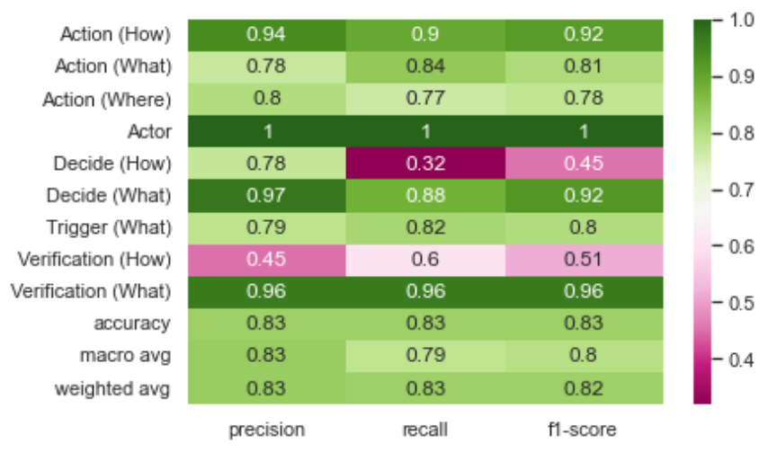

Figure 36: SGD classification report noise labels removed.

At the time of fine-tuning the SGD classifier, the following parameters were considered (Loss, penalty and l1 ratio). The best performance was achieved by utilizing consecutively hinge for loss, penalty setup at l2 and l1 ration as 0. This helps the model reach the second-best performance model at 84.24% accuracy.

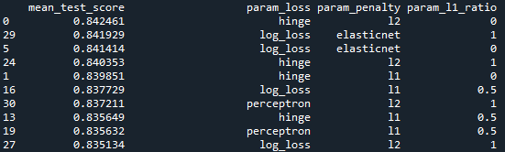

Table 9: SGD parameters fine-tuning.

In addition, during the process of the fine-tunning, a cross validation method was developed for all models to overall text which models preformed the best compared with the following cross validation method with cv parameter as 5 to test the different machine learning classifiers. On this test, SVC and XGBoost had the highest outliers while the SGD classifier had most of the results grouped on a short interval.

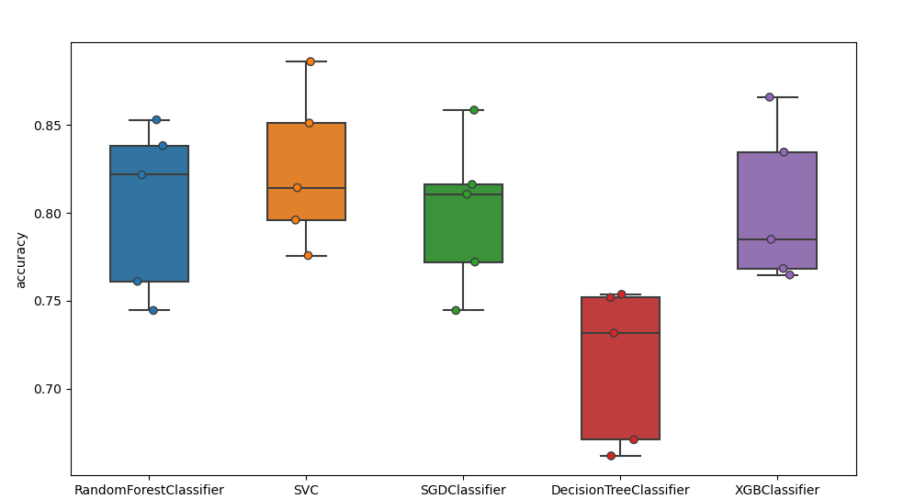

Figure 37 Cross-validation for the 5 main models.

## Sequence Analysis

For the labels that have poor accuracy scores, the team explored sequential analysis using 4 separate different sequence iterations. The chronological order shown on the left in the figure below comes from Jomana’s experience in SOP step structure. An alternative order is shown on the right.

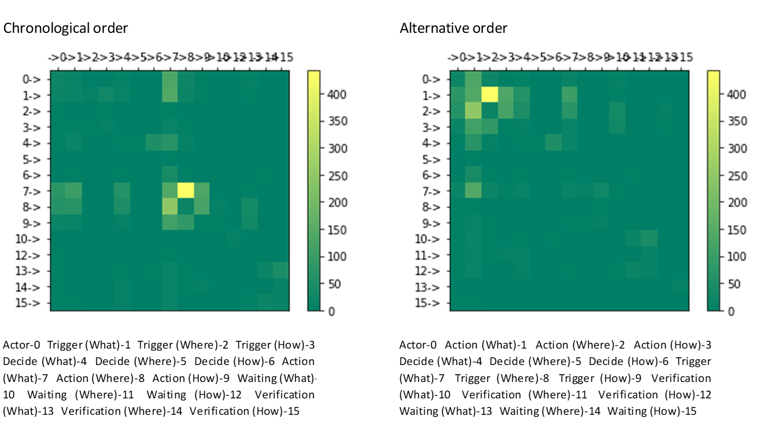

Figure38 : Labels sequence frequency - Chronological and Alternative

As it can be seen, the higher the pair of sequences show the yellower the color will be. The figures above show these sequences for all label available in the dataset, most of the sequence pairs that can be seen are related to Action (What) – Action (Where), Action (Where) – Action (What) with the first pair been the most predominant one.

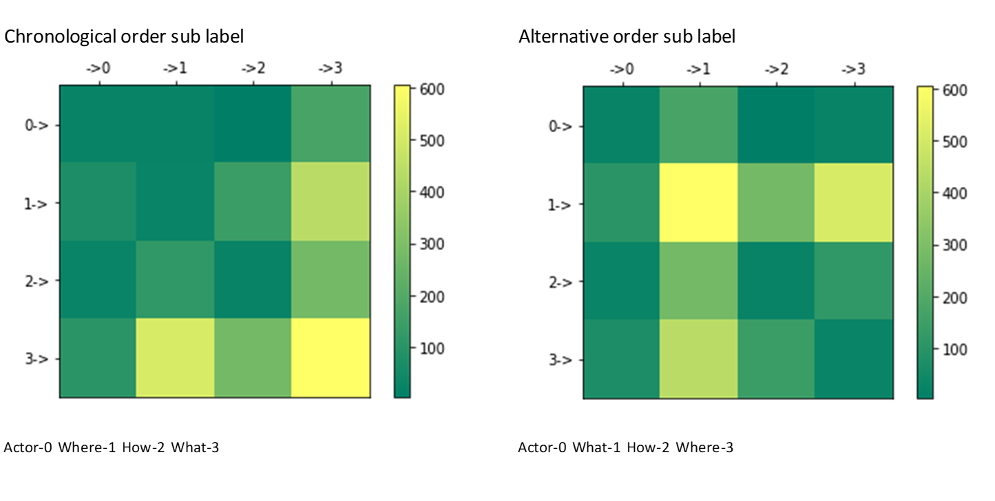

Figure 39: Sub labels sequence frequency - Chronological and Alternative

In addition to the label pair sequence analysis, the sub label portion of the label was also checked. On both figures below the chronological and alternative order or the sublabels heatmap can be seen, which most of the sequence pairs related to What – What, What – Where and Where – What. By looking at the parent label and the sub label pair of sequences, it can be deducted from this that our most frequent pair is Action (What) – Action (Where) and that an important part of the pair in the dataset are related to the sub label What – What sequence. This might imply that in most cases labels do not always use all sub label available, since they might not be present in the current SOP process that’s been labeled.

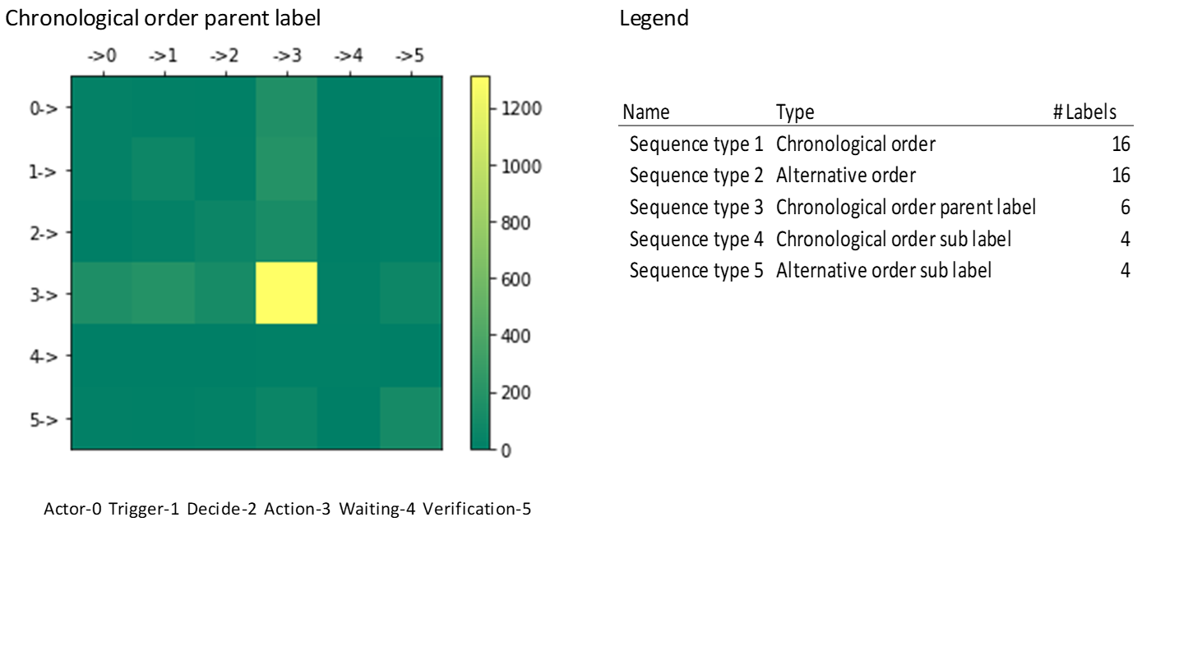

Figure 40: Parent label sequence frequency - Chronological

Finally for the sequence pairs, also the parent label was analyzed which can be seen on Fig. 29. This last visual reiterates that Action – Action has an important part of the pairs on the dataset but also that there is an important portion of labels related to Action -Trigger or vice versa Tigger – Action.

For each sequence, a sequential algorithm was computed that helps to predict the 4 steps on each 3-step sequence. For this, the TensorFlow and Keras package was used, and the following layers were added to the model. The accuracy provided by this algorithm was 33.8% for the alternative order suggested by the team.

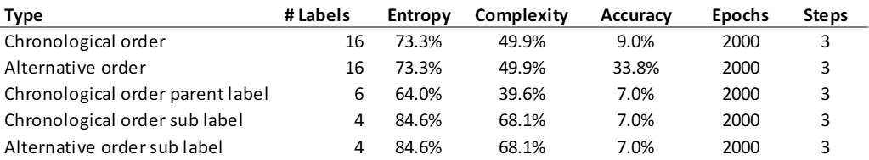

Table 10: Sequence frequencies and their results.

Given the high entropy calculated on Table below and the complexity of the sequences accompanied by a low accuracy score, the team didn’t explore in depth the sequence analysis until more information could be extracted for this purpose from the annotations in UBIAI.

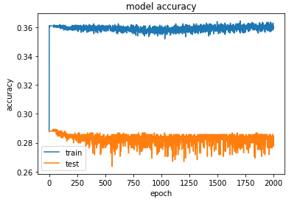

Figure 41: Accuracy vs # epoch for the alternative order.

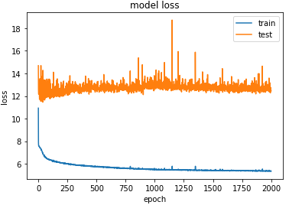

Figure 42: Loss vs # epoch for the alternative order.

# Findings

Procedures related to takeoff, landing and approach had the most Action-Actor-Decide explicitly mentioned. Out of the 45 procedures annotated and analyzed, the Action-Actor-Trigger was mentioned explicitly 69% of the time. It is critical for SOPs to contain these 3 labels especially during landing and takeoff checks as actions and callout eliminate or lower the chance of mistakes or misses pilots can make when completing procedures.

Actors were explicitly mentioned in only 60% of the SOPs that were annotated for this study. It is crucial to clearly list the responsible individual performing a step of the SOP. This helps avoid skipping steps and confusion between pilot or first officer. According to the FAA SOP guidance book, good procedures include “who is responsible for executing each step in the procedure”. [21]



Figure 43: Overall model vs testing 3 new SOPs.

Testing was done on 3 SOPs not included in the training data set of the NLP model. The result was lower than expected as the f1-score of the testing result was 0.61 compared to 0.84 for the overall model. We can also notice the 3 SOPs tested did not have any waiting labels which can result in a lower f1-score. As the Waiting label was one of the least encountered during our annotation and data collection process, this test removed that category to also test if our models work better without these low count labels. Action labels have outperformed the other labels like the overall model. This is mainly due to the data availability for Action labels in SOPs. This goes in accordance with guidance provided by the Advisor Circular (AC) for developing and designing SOPs.

After the fine tuning was completed, the best model to perform was the XGBoost, with the parameters configured as: for the booster = gblinear, max depth setup as 1 and the number of estimators as 100. This configuration for this model resulted in an 84% score for precision, recall, f1-scores, and accuracy. It is important to mention that the second algorithm that performed like the XGBoost was the Stochastic gradient descent with a final accuracy of 82%.

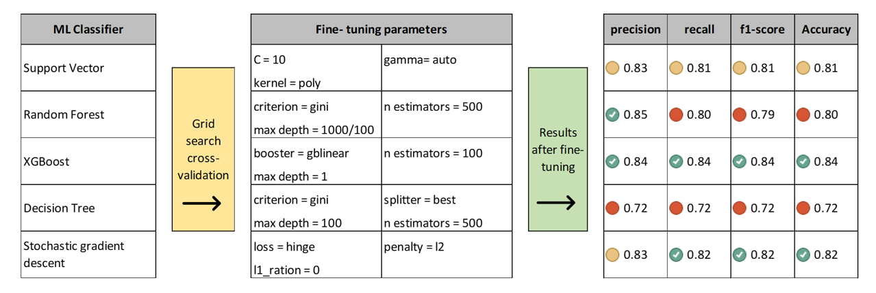

Figure 44 Model fine-tunning, parameters and final results.

# Summary

## NLP in a nutshell

The roadmap below shows all the steps taken by the team to create an NLP model that classifies SOPs into labels. The team collected both annotated and PDF versions from Jomana. The annotated SOPs were in Json format, and the unannotated SOPs were annotated using UBIAI, an annotation tool. These annotated SOPs need to go through cleansing or cleaning process as UBIAI combines some strings together when annotating. We also created a dictionary for some of the most common acronyms and abbreviations we collected from these SOPs. Using this dictionary, we replaced the abbreviations with their non-abbreviated equivalents.

Several deterministic rules were set in the second vector to help the algorithm make easier decisions when it comes to easy decisions. Table 2 shows the deterministic rules we have used in this paper. Decide (What) has conditional statements, starts with or contains an if statement, and the deterministic rule will label the text as Decide (What) if it contains a conditional statement. Verification labels similarly contain verification statements so the algorithm can easily predict that label.

The team compared numerous classifiers to find the best performing ones. We also investigated using separate or different classifiers for some of the labels as they perform better in certain classifiers than others. After selecting our best performing model, the team tested the model with annotated SOP that was not used in the training model. The results, posted in figure 30 above, were lower than expected and lower than the trained model. Finally, the team also created a script that converts scanned pdfs into text files which can be run in our model to automatically annotate the document to analyze the SOP.

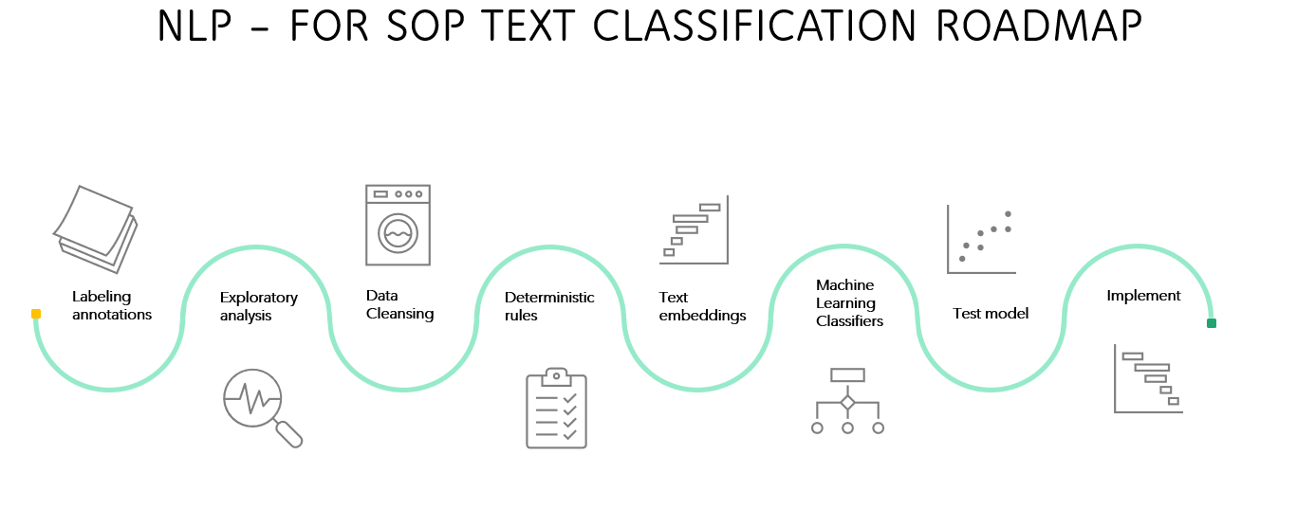

Figure 45: Text classification in a Nutshell

# Future Work

Through the end of the project, the team identified possible recommendations and opportunities for further work which can be separated into three main topics.

## Additional annotation for sequence analysis

Since there are labels hard to predict by the text they are tied into, acquiring more information in regards the sequence of each process in the annotation tool is crucial. This will help in future work to provide a more robust sequence analysis and the understanding of the start and end of each process. This sequence analysis will help predict the next label based on the previous sequence with more information that hopefully could be used for better predictions.

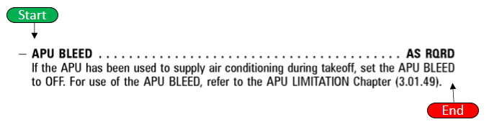

Figure 46 Annotation of an SOP: Start point and end point.

## Simulated dataset to mitigate label scarcity

On all SOPs annotation done by our partner and the team, there are labels that had few datapoints on the dataset and are not considered in the results. For this reason, the team recommends simulating these labels by a method that can consider all types of communalities related to their parts of speech, sentence structure, sequence, or even deterministic rules they could contain. For example, for the label Waiting, from the few records in the database most of the instances a preposition of time like (until, after, by, etc.) appears on the text followed by time represented by either seconds, minutes or hours. So given these deterministic rules, it could help to assume some possible text that these field could have by generating several of these combinations for the model to absorb and be trained with.

## Ensemble modeling

Finally, additional work is recommended on exploring the possibility of creating an ensemble modeling or hybrid model that can merge different types of models into one single model. This is to take the benefits of BERT algorithms, deterministic rules, and possibly more predicting power a sequence analysis model could give on predicting SOPs labels.

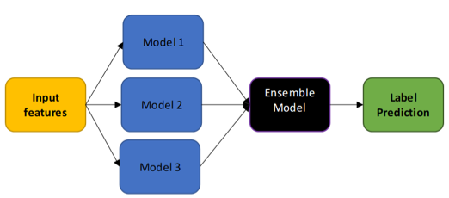

Figure 47 Ensemble modeling, combination of several models to generate final prediction.

# Appendix A: Code References

## Github

Link: <https://github.com/Chargers-Team/202270-010-Team-The-Chargers-Project-Development-->

## Readme file

**DEAN 690 Fall Project**

Professor: Brett Berlin

Organization: GMU Center for Air Transportation Systems Research (CATSR)

Project POC(s): Dr. Lance Sherry, Director CARST, [lsherry@gmu.edu](mailto:lsherry@gmu.edu) and Jomana Bashatah, jbashata@gmu.edu

Team Chargers has the task of working with Standard Operating Procedures from the airline industry, specifically to solve the following question.

For the airline industry’s Standard Operating Procedures (SOPs) defined as Flight Crew Operators Manuals (FCOM)/ Airplane Flight Manual (AFM) can Natural Language Processes tools be implemented to classify and detect the 4 main activities already preestablished as Action, Decision-Action, Action-Waiting-Verification, and Decision-Action with Waiting-Verification?

**Problem Scope**

Standard Operating procedures (SOPs) are documented step by step instructions followed by human operators which are essential to perform critical, repetitive, complex, and emergency-related tasks as efficiently as possible. Due to these aspects and since SOPs play an important role in any type of process, it's critical to find a systematic method to quantify their information. Nowadays SOPs are created manually by a subject matter expert in the field, which is a time-consuming and tedious process to follow. In addition to this, these documented instructions usually are in formats that are difficult to systematically extract any type of data from. The challenge of the project will be to extract useful statistical information from SOPs to help future research on their possible automation when created to reduce costs, improve training and as well most important increase safety and reduce human error. The methodology and logic of the project are going to be applicable to any SOPs, however, due to time constraints our focus is going to be based in the airline industry defined by the operation manuals used by pilots like the Flight Crew Operators Manual (FCOM) or Airplane Flight Manual (AFM).

**Github folder structure**

Documents: Contains all algorithm comparison the team did before picking the best performing one.

Python: Contains python scripts used for building NLP model and testing.

Data: Contains all annotated data collected from UBIAI tool. Files are cleaned after downloading from UBIAI before being used in NLP model.

Model_results: Contains model results we get after running the model.

Visualizations: Contains all visualizations used for report. The report explains the visuals we get when running the model and sequential analysis. Test:

**Data**

The dataset used for this model was collected from SOPs annotated by Jomana and SOPs annotated by our team. We cleaned the data after annotating and replaced some airline acronyms or short words, so the algorithm does not get confused with other words.

# Appendix B: Risk Section

## Sprint 1 Risks

|  |  |  |  |  |
| --- | --- | --- | --- | --- |
| **Risk Name​** | **Description​** | **Probability ​** | **Impact​** | **Mitigation​** |
| Scope creep​ | Changes in the project without proper planning​ | Low​ | High​ | - Have a change management plan​  -Create and follow project schedule​ |
| Algorithm selection​ | Find the best algorithm and tool to annotate SOP​ | Low​ | Medium​ | - Research on several tools/algorithms to find the best one that works for our project​ |
| Annotation accuracy​ | Find a way to increase annotation accuracy to have the best training dataset for NLP​ | High​ | Medium​ | - Have multiple team members annotate the same SOP to increase accuracy​ |

Table 11: Risks Sprint 1

Risks for Sprint 1 were assessed and identified based on how the risks would affect our problem statement. Our highest impact risk and low probability was Scope creep. We did encounter a setback where one of our team members left the project early in the project lifecycle. This did not affect our schedule for completing Sprint 1 as we were able to make necessary changes early in the project lifecycle.

Another important risk that came up during our weekly meeting with Dr. Sherry was annotation accuracy. To provide accurate annotated data for our NLP code or analysis, we decided to have multiple team members annotate the same SOP to increase accuracy. Even though this process was time consuming, it increased the accuracy of our annotated dataset. We also researched other types of annotating and parsing tools for their options in mitigating the accuracy between multiple users' annotations.

## Sprint 2 Risks

|  |  |  |  |  |  |
| --- | --- | --- | --- | --- | --- |
| **Risk Name** | **Description** | **Probability** | **Impact** | **Mitigation** | **Status** |
| Annotation Accuracy | UBIAI verification score | High | Medium | 2 team members annotate a SOP, the other 2 team members verify | Resolved |
| NLP Model  Accuracy Score | NLP classification accuracy based on raw data provided | Medium | High | Get more raw data or duplicate current dataset | Resolved |
| Diverse SOP | Currently large volume of action annotations | Medium | Medium | Looking for more SOP that include other decisions | Ongoing |

Table 12: Risks Sprint 2

As we moved into sprint 2, the team discussed a new set of risks. We continued to have two team members annotate a SOP while the other 2 team members verified that annotation. Doing this method allowed us to increase our UBIAI verification score. We resolved this risk. The second risk is the NLP model accuracy score based on the raw data provided. The annotation process was very time consuming, and the team worked hard to complete them. However, as we continued to annotate, we used duplicated data until we completed more annotations. This risk had a high impact level because our model was dependent on the fact that we had enough data to increase the model's accuracy.

The third risk was addressed in one of our weekly meetings with Dr. Sherry. At that time, there was a large volume of action labeled annotations. The current set of SOPs was not very diverse. Jomana worked to look for more SOPs that included some additional labels such as trigger, waiting, and verification. This risk was marked as ongoing, as we continued to receive more SOPs from Jomana on a bi-weekly basis.

## Sprint 3 Risks

|  |  |  |  |  |  |
| --- | --- | --- | --- | --- | --- |
| **Risk Name** | **Description** | **Probability** | **Impact** | **Mitigation** | **Status** |
| Model   overfitting | Model will be overfitted when duplicating data | Medium | High | Do not duplicate data | Ongoing |
| Complex data | Some annotated data are too complex to classify and predict | Medium | Medium | Use readability index to remove or clean complex | Ongoing |
| NLP outside help | Find expert in NLP to help with our codes. | High | High | Prepare ask for Dr. Berlin and send a reminder | Ongoing |
| Diverse SOP | Currently large volume of action annotations | Medium | Medium | Looking for more SOP that include other decisions | Ongoing |

Table 13: Risks Sprint 3

In sprint 3 the team identified three additional ongoing risks. At that time, there was a risk of the model being overfitted due to data duplication. To resolve this the team continued to annotate additional SOPs to help diversify the data set. Another risk the team ran into was the complexity of the data set creating complications in the classification and prediction of the model. To combat this risk, we created a readability index to help clean up the model's complex data.

The team began looking for outside help from a subject matter expect pertaining to NLP models. The team continued to mitigate these risks as we entered sprint 4.

## Sprint 4 Risks

|  |  |  |  |  |  |
| --- | --- | --- | --- | --- | --- |
| **Risk Name** | **Description** | **Probability** | **Impact** | **Mitigation** | **Status** |
| Model overfitting | Model will be overfitted when duplicating data | Medium | High | Do not duplicate data | Resolved |
| Complex data | Some annotated data are too complex to classify and predict | Medium | Medium | Use readability index to remove or clean complex | Resolved |
| NLP outside help | Find an expert in NLP to help with our codes. | High | High | Prepare ask for Dr. Berlin and send reminder | Reached out to Jinding Xing, who is working on a similar project in nuclear power plant SOPs |
| Diverse SOP | Currently large volume of action annotations | Medium | Medium | Looking for more SOP that include other decisions | Ongoing |
| Parsing SOPs | Issue with parsing SOP with Python | High | High | Need to find a way to parse text documents that can be fed to the NLP model | Ongoing |
| Converting pdf SOP to text file | Python script having a tough time with structure of SOPs | Medium | Medium | Add more parameters to script to recognize bold | Resolved |
| TensorFlow | Implementing the TensorFlow algorithm and applying it to the model can take more time than initially planned. | Medium | High | Set a hard deadline for when to apply to model | Resolved |

Table 14: Risks Sprint 4

The first two risks Model Overfitting and Complex Data were resolved using the mitigations listed in the table. For the NLP help, a team member identified a draft research article of interest concerning a similar project and reached out to the author for more details. They were able to provide documents to confirm the approach used was appropriate. The diverse SOPs risk was more so an assumption or a point for clarification. Since all steps have an action component, there will always be significantly more of these labels. Therefore, the team knew that the non-action labels would benefit from deterministic rules as discussed in the paper. Converting pdf SOPs to text files was identified as a risk this sprint and was resolved by adding more parameters to the script, for example, the script to recognize bold text. Although the conversion wasn’t perfect, this continued to be an important part of the process in which automation was beneficial. TensorFlow was identified as a useful tool for the sequential analysis that the team employed for some of the non-action labels. The team had two options to execute this algorithm via Hopper Cluster and Google Collab. Google Collab proved simpler for the task at hand.

## Sprint 5 Risks

|  |  |  |  |  |  |
| --- | --- | --- | --- | --- | --- |
| **Risk Name** | **Description** | **Probability** | **Impact** | **Mitigation** | **Status** |
| Diverse SOP | Currently large volume of action annotations | Medium | Medium | Looking for more SOP that include other decisions | Resolved |
| Parsing SOPs | Issue with parsing SOP with Python | High | High | Need to find a way to parse text documents that can be fed to the NLP model | Resolved |

Table 15: Risks Sprint 5

As the team transitioned to sprint 5, focus was shifted to summarizing the findings and preparing for the final presentation. The previous risks that were ongoing moved into a future work consideration.

# Appendix C: Agile Development

## Scrum Methodology

## Sprint 1 Analysis

Sprint 1 focused on understanding the problem statement and the reason and importance of the project. We tried to identify and make sprints small enough to be completed in one Sprint and independent to make one user story different from another. It was difficult to formulate user stories in our first week, but we have been adapting and practicing creating user stories and the videos on blackboard have been very helpful.

It was not hard to manage the tasks for Sprint 1 because the requirements for this sprint were not as extensive as the coming ones. We were able to define the problem statement with the help of Dr. Sherry and received part of our dataset from Jomana where she also explained what we are required to do with the dataset.

## Sprint 2 Analysis

Sprint 2’s focus was around datasets. We had two main sections of data to work with. First the annotated SOPs in JSON format provided a good start to build an NLP model and perhaps, more importantly, we could begin identifying key areas for improvement. One major improvement we could identify was the necessity to convert abbreviations into full words. Since our project focuses on the Aviation industry, we could find some great resources tailored to our purpose of replacing aviation abbreviations. Something else that stuck-out to us was the uneven quantity of labels. There are significantly more Action labels than Waiting labels, so we started to explore duplicating data to improve model prediction. What is better is to get more actual data because often the phrases label waiting for example would be the exact same phrase. While that makes the model good at detecting that exact phrase, the team felt apprehensive about the usefulness of this approach.

The second data section was the SOPs yet to be annotated. Jomana worked to gather these for us and upload them to UBIAI where we used her flowchart to tag labels. We experienced a bit of a learning curve with annotation accuracy and utilized the Inter Annotator Assessment score to better gauge the annotation accuracy. Working together in groups of two seemed to help decide how to label the variety of phrases. This takes time to align on as a team and clarifies how the data will be input into the model.

## Sprint 3 Analysis

For Sprint 3, the focus shifted to algorithms and analysis. We continued to annotate SOPs to build the dataset for training the model. The abbreviation replacement code was written in such a way that we could just add abbreviations and their replacements as we needed to. Another key effort was around cleaning the data from UBIAI. A few python packages were identified to help improve the classification of the model. Combining pertinent classifiers like parts of speech and readability scores helped the accuracy of the algorithm. We continued to see improvements to the model as we replaced many abbreviations and corrected spelling errors that were mostly due to UBIAI’s shortcomings on reading in the documents.

## Sprint 4 Analysis

Sprint 4 was all about visualizations and Machine Learning model training and evaluation. The team tried different classifiers for the model and explored ways to display the results. The broader picture of combining cleaning techniques and using multiple models started to become more feasible. The team stopped annotating SOPs and learned that the variety of labels regarding accuracy in predictive power was an issue for the model that could be solved with deterministic rules and potentially sequence analysis. Since all steps had an action label and only some steps would have additional labels, it made sense that the infrequent labels required unique modeling.

## Sprint 5 Analysis

As the team transitioned to sprint 5, summarizing the work became the goal. The team looked back to the original request from the client and began framing results in a way that ties into the original work done by J. Bashatah and Dr. Sherry. The insights from the Carnegie Mellon University paper on Nuclear Power plant operating procedures were very useful in summarizing the results from the team’s efforts over the semester.

# References

|  |  |
| --- | --- |
| [1] | R. Kundu, "livemint," 12 September 2021. [Online]. Available: https://www.livemint.com/companies/news/nonadherence-to-sop-led-to-crashaaib-11631473317252.html. [Accessed 28 October 2022]. |
| [2] | I. Duncan, "40 years ago, a 737 crashed into the 14th Street Bridge during a snowstorm, killing 78.," The Washington Post, 14 January 2022. [Online]. Available: https://www.washingtonpost.com/transportation/2022/01/13/air-florida-crash-40-years/ . [Accessed 28 October 2022]. |
| [3] | C. N. Giles, "Modern Airline Pilots' Quandary: Standard Operating Procedures - to comply or Not to Comply," 14 March 2013. [Online]. Available: https://docs.lib.purdue.edu/jate/vol2/iss2/1/. [Accessed 1 October 2022]. |
| [4] | J. Bashatah and D. L. Sherry, *Method for Formal Analysis of the Type and Content of Airline Standard Operating Proceures,* Fairfax: unpublished, 2022. |
| [5] | D. Kortenkamp, R. P. Bonasso, D. Schreckenghost, K. M. Dalal, V. Verma and L. Wang, "A Procedure Representation Language for Human Spaceflight Operations," p. 8, 2008. |
| [6] | L. D. Sherry, *Modernizing Development, Deployment and Monitoring of Standard Operating Procedures (SOPs),* Unpublished, 2022. |
| [7] | J. Andales, "SOP meaning: Standard operating procedure," Safety Culture, 10 Sep 2022. [Online]. Available: https://safetyculture.com/topics/sop/. [Accessed 11 Sep 2022]. |
| [8] | SKYbrary Aviation Safety, "Flight crew operating manual (FCOM)," SKYbrary Aviation Safety, [Online]. Available: https://skybrary.aero/articles/flight-crew-operating-manual-fcom. [Accessed 1 Sep 2022]. |
| [9] | Federal Aviation Administration, "Handbooks & Manuals," Federal Aviation Administration, [Online]. Available: https://www.faa.gov/regulations_policies/handbooks_manuals. [Accessed 1 Sep 2022]. |
| [10] | U. Mishra, "Top 10 NLP algorithms: Analytics steps," [Online]. Available: https://www.analyticssteps.com/blogs/top-nlp-algorithms. [Accessed 29 Aug 2022]. |
| [11] | P. Neupane, "Text classification in Natural Language Processing," Analytics Vidhya, 11 Dec 2020. [Online]. Available: https://www.analyticsvidhya.com/blog/2020/12/understanding-text-classification-in-nlp-with-movie-review-example-example/. [Accessed 02 Sep 2022]. |
| [12] | huggingface, "Bert 101 - state of the art NLP model explained," hugging Face, [Online]. Available: https://huggingface.co/blog/bert-101. [Accessed 01 Sep 2022]. |
| [13] | B. Lutkevich, "What is Bert (language model) and how does it work?," SearchEnterpriseAI, 27 Jan 2020. [Online]. Available: https://www.techtarget.com/searchenterpriseai/definition/BERT-language-model. [Accessed 02 Sep 2022]. |
| [14] | IBM, "What is optical character recognition (OCR)?," IBM, [Online]. Available: https://www.ibm.com/cloud/blog/optical-character-recognition. [Accessed 29 Aug 2022]. |
| [15] | dida Machine Learning, "The best free labeling tools for text annotation in NLP," dida Machine Learning, [Online]. Available: https://dida.do/blog/the-best-free-labeling-tools-for-text-annotation-in-nlp. [Accessed 06 Sep 2022]. |
| [16] | J. Oxstrand, K. Le Blanc and A. Bly, "Light Water Reactor Sustainability Program.," 14 September 2014. [Online]. Available: https://inldigitallibrary.inl.gov/sites/sti/sti/6278340.pdf. [Accessed 2022]. |
| [17] | B. Schwartz, "Welcome Bert: Google's latest search algorithm to better understand natural language," 23 February 2022. [Online]. Available: https://searchengineland.com/welcome-bert-google-artificial-intelligence-for-understanding-search-queries-323976. [Accessed 18 October 2022]. |
| [18] | M. Hofmann, "Support Vector Machines -Kernels and the Kernel Trick an Elaboration for the Hauptseminar," *Reading Club: Support Vector Machines.,* 2006. |
| [19] | A. Kumar, "SVM Classifier Using Sklearn: Code Examples.," 6 May 2022. [Online]. Available: vitalflux.com/svm-classifier-scikit-learn-code-examples/. [Accessed 2022]. |
| [20] | Sartorius, "What is principal component analysis (PCA) and how it is used?," 18 August 2020. [Online]. Available: https://www.sartorius.com/en/knowledge/science-snippets/what-is-principal-component-analysis-pca-and-how-it-is-used-507186. [Accessed 21 October 2022]. |
| [21] | "] Advisory Circular Subject: Standard Operating Procedures and Pilot Monitoring Duties for Flight Deck Crewmembers.," 10 January 2017. [Online]. Available: https://www.faa.gov/documentlibrary/media/advisory_circular/ac_120-71b.pdf. [Accessed 28 October 2022]. |
| [22] | K. S. Tai, R. Socher and C. D. Manning, "Improved Semantic Representations From Tree-Structured Long Short-Term Memory Networks," 2015. [Online]. Available: https://arxiv.org/abs/1503.00075. [Accessed September 2022]. |
| [23] | L. J., "Introducing BERT: Google’s New AI Algorithm," business2community, 19 Oct 2019. [Online]. Available: https://www.business2community.com/brandviews/shelley-media-arts/introducing-bert-googles-new-ai-algorithm-02254206. [Accessed 03 Sep 2022]. |

# Glossary

|  |  |  |
| --- | --- | --- |
| **Term** | **Definition** | **Link** |
| **Accuracy** | fraction of predictions model is correct | https://developers.google.com/machine-learning/crash-course/classification/accuracy |
| **Complexity index** | computes the complexity index, a composite measure of sequence complexity. The index uses the number of transitions in the sequence as a measure of the complexity induced by the state ordering and the longitudinal entropy as a measure of the complexity induced by the state distribution in the sequence. | http://traminer.unige.ch/doc/seqici.html |
| **Deterministic rules** | Hard-coded rules that are applicable in any case. | https://towardsdatascience.com/hybrid-rule-based-machine-learning-with-scikit-learn-9cb9841bebf2 |
| **f1-score** | The F1 score is a weighted harmonic mean of precision and recall such that the best score is 1.0 and the worst is 0.0. Generally speaking, F1 scores are lower than accuracy measures as they embed precision and recall into their computation. As a rule of thumb, the weighted average of F1 should be used to compare classifier models, not global accuracy. | https://developers.google.com/machine-learning/crash-course/classification/precision-and-recall |
| **Feature** | x are descriptive attributes/variables. | https://developers.google.com/machine-learning/crash-course/framing/ml-terminology |
| **High feature cardinality** | Number of possible values for a feature. | https://towardsdatascience.com/hybrid-rule-based-machine-learning-with-scikit-learn-9cb9841bebf2 |
| **Hyperparameters** | values or weights that determine the learning process of an algorithm | https://www.kaggle.com/code/prashant111/a-guide-on-xgboost-hyperparameters-tuning/notebook |
| **Label** | y is what is attempting to be predicted | https://developers.google.com/machine-learning/crash-course/framing/ml-terminology |
| **Precision** | Precision is the ability of a classifier not to label an instance positive that is actually negative. For each class it is defined as the ratio of true positives to the sum of true and false positives. | https://developers.google.com/machine-learning/crash-course/classification/precision-and-recall |
| **recall** | Recall is the ability of a classifier to find all positive instances. For each class it is defined as the ratio of true positives to the sum of true positives and false negatives. | https://developers.google.com/machine-learning/crash-course/classification/precision-and-recall |
| **Shannon entropy** | a data communication system composed of three elements: a source of data, a communication channel, and a receiver. The "fundamental problem of communication" – as expressed by Shannon – is for the receiver to be able to identify what data was generated by the source, based on the signal it receives through the channel. | https://en.wikipedia.org/wiki/Entropy_(information_theory) |
| **Tensor** | mathematical objects that can be used to describe physical properties, just like scalars and vectors. In fact tensors are merely a generalization of scalars and vectors; a scalar is a zero rank tensor, and a vector is a first rank tensor. | https://www.doitpoms.ac.uk/tlplib/tensors/what_is_tensor.php |
| **inflect** | Correctly generate plurals, singular nouns, ordinals, indefinite articles; convert numbers to words. | https://pypi.org/project/inflect/ |
| **Keras** | open-source software library that provides a Python interface for artificial neural networks. Keras acts as an interface for the TensorFlow library. | https://keras.io/ |
| **matplotlib.pyplot** | state-based interface to matplotlib. It provides an implicit, MATLAB-like, way of plotting. It also opens figures on your screen, and acts as the figure GUI manager. | https://matplotlib.org/3.5.3/api/_as_gen/matplotlib.pyplot.html |
| **nltk** | The Natural Language Toolkit, or more commonly NLTK, is a suite of libraries and programs for symbolic and statistical natural language processing for English written in the Python programming language. | https://www.nltk.org/ |
| **numpy** | library for the Python programming language, adding support for large, multi-dimensional arrays and matrices, along with a large collection of high-level mathematical functions to operate on these arrays. | https://numpy.org/doc/stable/user/absolute_beginners.html#:~:text=NumPy%20can%20be%20used%20to,on%20these%20arrays%20and%20matrices. |
| **os** | module provides a portable way of using operating system dependent functionality. | https://docs.python.org/3/library/os.html |
| **pandas** | software library written for the Python programming language for data manipulation and analysis. In particular, it offers data structures and operations for manipulating numerical tables and time series. | https://pandas.pydata.org/ |
| **Pysan** | library is a collection of methods for doing sequence analysis. | https://pypi.org/project/pysan/ |
| **re** | module text manipulation that provides regular expression matching operations similar to those found in Perl. | https://docs.python.org/3/library/re.html |
| **seaborn** | data visualization library based on matplotlib. It provides a high-level interface for drawing attractive and informative statistical graphics. | https://seaborn.pydata.org/ |
| **spacy** | free open-source library for Natural Language Processing in Python. It features NER, POS tagging, dependency parsing, word vectors and more. | https://spacy.io/ |
| **spacy_sentence_bert** | package wraps sentence-transformers (also known as sentence-BERT) directly in spaCy. You can substitute the vectors provided in any spaCy model with vectors that have been tuned specifically for semantic similarity. | https://github.com/MartinoMensio/spacy-sentence-bert |
| **TensorFlow** | open-source software library for machine learning and artificial intelligence. It can be used across a range of tasks but has a particular focus on training and inference of deep neural networks. | https://www.tensorflow.org/ |
| **textblob** | library for processing textual data. It provides a simple API for diving into common natural language processing (NLP) tasks such as part-of-speech tagging, noun phrase extraction, sentiment analysis, classification, translation, and more. | https://textblob.readthedocs.io/en/dev/ |
| **textstat** | library to calculate statistics from text. It helps determine readability, complexity, and grade level. | https://pypi.org/project/textstat/ |
| **wordninja** | package to slice your munged together words | https://github.com/keredson/wordninja |